HYDRA Documentation



CAQ Statuses
CAQ Status Configuration
Contents
1 Introduction to HYDRA CAQ Statuses 3
1.1 Maintenance of statuses from MES Weaver 2.0 onwards 3
1.2 Maintenance of statuses before MES Weaver 2.0 3
1.3 Transcription of statuses at runtime 7
2 Overview of status types 8
3 Description and configuration of statuses 11
Status type: ANAWEINTTYP - Type of entries for failure analysis catalogs 11
Status type: ANAWFLTTYP – Filter types for the entries of failure analysis catalogs 11
Status type: BASIS_PRFERG_MM – Data base to determine the inspection result of a characteristic 12
Status type: BEREICHSTYP – area types 12
Status type: BERXQART – Default values to calculate statistics XQ 13
Status type: BEWART_MERK evaluation types of characteristics 13
Status type: BEWART_SP – evaluation types of samples 14
Status type: BEWELEMPROG – assessment programs for elements 14
Status type: BEWELEMQUELLE – source for the evaluation of elements 15
Status type: BEWSTATUS – evaluation type 15
Status type: BEWTYP – Evaluation types 16
Status type: CAQ_TABELLEN – CAQ tables 17
Status type: CPLFREIGABE – List item of released control plans 17
Status type: DEVICETYP – Device types 18
Status type: DOKTYP – Document types 19
Status type: DOKUPFLICHT – Status of required documentation 19
Status type: DYNART – Dynamic modification types 20
Status type: DYN_SP_DATEN_BASIS – Data base for dynamic modification relating to samples 21
Status type: DYN_STPRANW_TYP – Types of sampling plans 21
Status type: EGWEINS – Action probability for unilateral distribution 22
Status type: EGWZWEI – Action probability for bilateral distribution 23
Status type: EGWZWEI_RS – Action probability for bilateral distribution (r and s chart) 24
Status type: EMUFORM – Initial sample forms 25
Status type: EMUMMTYP_PPAP – EMU Assignment of characteristics according to PPAP EMUMMTYP_PPAP 25
Status type: EMUMMTYP_VDA22 – Initial sampling assignment of characteristics VDA volume 2, 2nd edition 26
Status type: EMUMMTYP_VDA23 – Initial sampling assignment of characteristics VDA volume 2, 3rd edition 26
Status type: ERFART – Input types 27
Status type: ERFASSART – Input types 28
Status type: ERFINT – Types of collection intervals 29
Status type: FEHLER_KLASSE – Defect classes 30
Status type: FHLANTYP – Failure analysis criteria 31
Status type: FHLBEW_EINHEIT – Units of defect evaluation 31
Status type: FHLGEW – Defect weighting 32
Status type: FIRMENTYP – Company type 32
Status type: FORMULARTYP – Form types (for printing) 33
Status type: INTERVAL – Intervals 34
Status type: KAT_BEWERTUNG – Catalog evaluations 34
Status type: KSTTYP – Cost types 35
Status type: MASSANGABE – Type of measurement 36
Status type: MASSNTYP – Measure types 36
Status type: MASSTATUS – Measure status 37
Status type: MDIKONFANSCHL – Types of MDI connections 38
Status type: MERKMAL_AKTION – Generation of inspection steps and characteristics 38
Status type: MERKSTATUS – Characteristic status 39
Status type: MERKTYP – Characteristic types 39
Status type: MESS_ATTRIBUT – Attributes for recorded values 40
Status type: MMTYP – Types of measuring equipment 40
Status type: MT_NORM – Standards for measuring tolerances 41
Status type: MUSSPRF – Status of mandatory inspections 41
Status type: NESTZUORD – Options for cavity assignment 42
Status type: NUMMERTYP – Number types 43
Status type: NUMPOOLBEARBSTA – Processing status of number pool entries 43
Status type: NUMPOOLSTA – Status of the number pool 44
Status type: PANERG – Inspection request results 45
Status type: PANSTATUS – Inspection request status 46
Status type: PANVERWENT – Usage decisions of inspection requirements 47
Status type: PAUAKTION – Options for the creation of inspection orders 47
Status type: PAUANMELD – Login status of the inspection order 48
Status type: PAUERG – Inspection order results 48
Status type: PAUPPLATZ – Options for relations between inspection orders and inspection stations 49
Status type: PAUSTATUS – Inspection order status 50
Status type: PMSTATUS – Test equipment (gage) status 50
Status type: PMVANZEXTEINF – PMV number of external influences 51
Status type: PMVMSABEZUG – PMV reference value for MSA capability test 52
Status type: PMVPRFBEFUND – Results of calibration/maintenance 52
Status type: PMVPRFREIHENF – PMV inspection sequence 53
Status type: PMVPRFVER – PMV inspection procedure 53
Status type: PMVPRUEFTYP – PMV inspection types 54
Status type: PMVVERWEND – Usage types for test equipment (gages) 55
Status type: PMVVORHSGEN – ??? 56
Status type: PPKTTYP – Types of inspection points 56
Status type: PPLAGCFG – Options for relations between inspection plans and operations 57
Status type: PPLSTATUS – Inspection plan status 57
Status type: PPLSUCH_AG – Methods to search for inspection plans (operation) 58
Status type: PPLSUCH_ATK – Methods to search for inspection plans (article data) 58
Status type: PPLSUCH_KD – Methods to search for inspection plans (customer data) 59
Status type: PPLSUCH_LIEF – Methods to search for inspection plans (supplier data) 59
Status type: PRFERG_MM – Inspection results of characteristics 60
Status type: PRFERG_STPR – Inspection results of samples 60
Status type: PRFZUSTAND – Inspection statuses 61
Status type: PRUEFART – Inspection types 61
Status type: PRUEFTYP – Inspection types 62
Status type: PRUEFUMF – Status of inspection scopes 63
Status type: QMS_ART – QMS - Type of inspection requirements 63
Status type: QMS_HERKUNFT – QMS - origin of the inspection requirement 64
Status type: QM_AG_CREATE – Generate operations if required 64
Status type: QUELLEDET – Sources for characteristic details 65
Status type: QUELLEDOKU – Source of documents 65
Status type: QUELLESPEZ – Sources for characteristic specifications 66
Status type: RECTYP – Data types 66
Status type: REGELK – Control Charts 67
Status type: REKART – Complaint types 68
Status type: REKBEFUND – Complaint results 69
Status type: REKDETBEFUND – Results of complaint details 69
Status type: REKDETSTATUS – Status of complaint details 70
Status type: REKDOKZUORD – Assignment of documents for complaints 71
Status type: REKSTATUS – Complaint status 71
Status type: STAT_VERTEILUNG – Statistical distribution types 72
Status type: STPLPLAN – Sampling schemes 72
Status type: TABELLENREF – Table reference 73
Status type: VERANTWTYP – Types of responsibilities 73
Status type: VERTEILVTYP – Types of responsibilities for distribution lists 74
Status type: WERKZUORD – Tool assignment 74
Status type: WFELEMENTTYP – Types of workflow steps 75
Status type: WFREF – Reference of workflows 76
Status type: WFTYP – Workflow types 76
Status type: ZERTIFDRU – Print options for certificates 77
Status type: Template – template for the description of a status type 77

Copyright

© Copyright 2009 MPDV Mikrolab GmbH. All rights reserved
MPDV® and HYDRA® are registered trademarks of MPDV Mikrolab GmbH.
Microsoft®, WINDOWS®, NT®, EXCEL®, Word®, SQL Server 2000® are registered trademarks of Microsoft Corporation.
UNIX® is a registered trademark of The Open Group in the United States and other countries.
ORACLE® is a registered trademark of Oracle Corporation, California, USA.
INFORMIX® is a registered trademark of Informix Software, Incorporated.
SAP® and R/3® are registered trademarks of SAP AG.
All other product and brand names are trademarks or registered trademarks of their respective owners.
The software provided by MPDV Mikrolab GmbH may contain components that are owned by third parties.

Copying and distribution of this documentation or any part thereof, for any purpose or in any form, is prohibited without prior written permission from MPDV Mikrolab GmbH.
The information contained in this documentation is subject to change without prior notice.

Introduction to HYDRA CAQ Statuses
With the aid of HYDRA-CAQ statuses HYDRA CAQ functions can be adapted to customer processes to a certain extent.
Every status is earmarked with the status type and the identifier of the status. The status type depicts the corresponding system function. The status identifier is saved in the database. For every status a long and short text is stored. The short text is primarily used for lists and dialogs having less space (e.g. in grids of the console and/or terminal). The long text contains the long version of the relevant status and is often used in fields for the corresponding input screens. The position can be used to determine the order of statuses in input elements (e.g. combo boxes and radio buttons).
Certain status lists can be extended with their own statuses (i.e. findings of complaints). Any other statuses are bound to their functions in the program. Only the description, the sequence or the parameters can be changed in some cases. But they may not be extended/modified.
All status types used in the system are sorted by the system area and listed with all parameters and functional features.

Maintenance of statuses from MES Weaver 2.0 onwards
From MES Weaver 2.0 onwards the statuses can be requested by calling of the corresponding menu item (CUS - CAQ - Status and/or CAQ - Master data - System administration - Status). This menu item is only available in HYDRA Professional Mode.

Maintenance of statuses before MES Weaver 2.0
Via a combination of keys Ctrl+Alt+d the following console screen is accessed. If opening the screen is not possible (e.g. due to a session for remote data transmission) then it can also be opened via the info dialog of the console in the "Support" tab by clicking the button "capls".
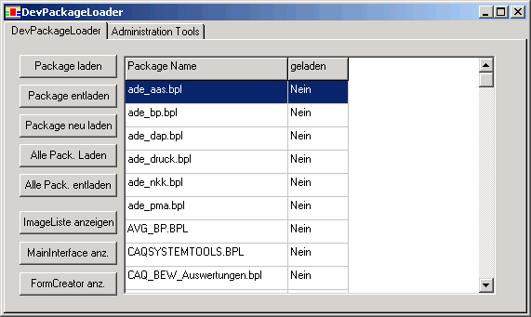
After clicking the button "FormCreator.anz" the following input screen appears:
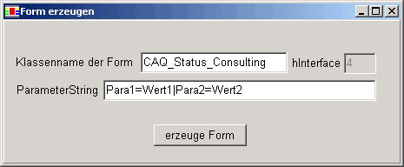
"CAQ_Status_Consulting" has to be entered here with "class name of form". The entry in the field "ParameterString" remains unchanged. Then the button "Generate form" has to be clicked. The "CAQ status" search screen appears.

WARNING: Unauthorized use of the SuperUser mode can lead to data inconsistencies!

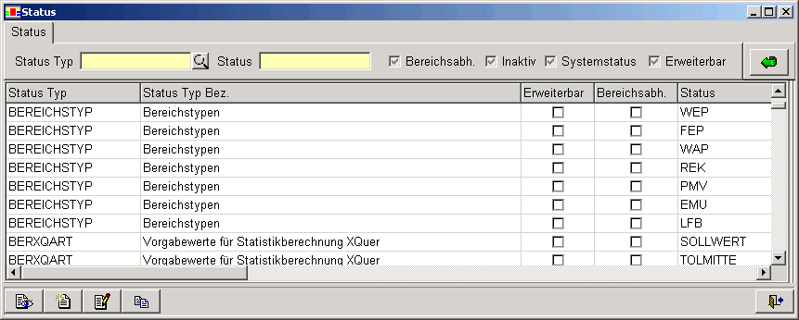
Note the following restrictions:
- Statuses cannot be deleted.
- A system status cannot be recreated.
- Only descriptions and positions can be changed for system statuses.
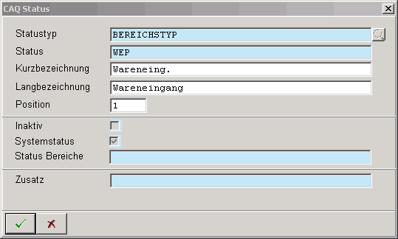

If in a status the "Addition" field is changed then this must be separated with commas and put in square brackets (see screenshot)
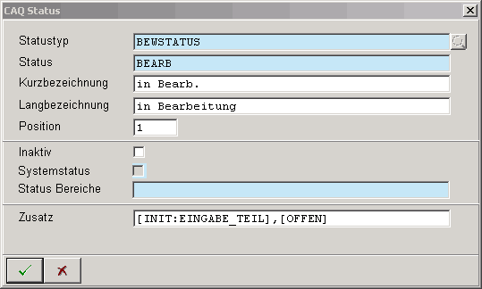

If in an area-dependent status "status areas" are changed then these must be separated by comma and put into square brackets (see screenshot):
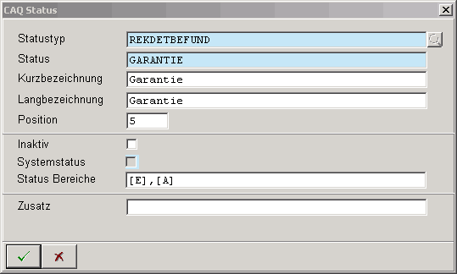

Transcription of statuses at runtime
The status identifiers supplied in the standard (long or short form) are translated when the console is in running mode. The required entries are stored in the HYDRA Dictionary. In column "Native" a key is entered to translate the short and long names:
CAQSTAT_<Status type>$<Status ID>_BEZK --> short form of the status
CAQSTAT_<Status type>$<Status ID>_BEZL --> long form of the status
Customer-specific terms requested as a status must be maintained in the customer dictionary. Otherwise, the unambiguous key (= cryptic text) will be shown at runtime if any other language than German is selected.
There is an option in the dictionary in the status search screen (see screenshot) by which you can view the native key and the respective German terms stored in the database(!) for the status list. Entries can be taken via Excel export and added to the dictionary.
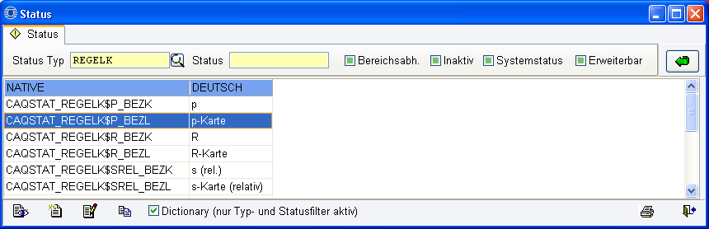

Overview of status types
Status type | Description of the status type | Editable | Extensible | Area-dependent
ANAWEINTTYP | Type of entries for failure analysis catalogs | NO | NO | YES
ANAWFLTTYP | Filter types for entries of failure analysis catalogs | NO | NO | NO
BASIS_PRFERG_MM | Data basis to determine the inspection result of a characteristic | NO | NO | NO
BEREICHSTYP | Area types | NO | NO | NO
BERXQART | Default values to calculate statistics XQ | NO | NO | NO
BEWART_MERK | Evaluation types of characteristics | YES | NO | NO
BEWART_SP | Evaluation types of samples | YES | NO | NO
BEWELEMPROG | Assessment programs for elements | NO | NO | NO
BEWELEMQUELLE | Source of evaluation of elements | NO | NO | NO
BEWSTATUS | Evaluation status | YES | YES | NO
BEWTYP | Evaluation types | YES | YES | NO
CAQ_TABELLEN | CAQ tables | NO | NO | NO
CPLFREIGABE | List item of released control plans | YES | YES | NO
DEVICETYP | Device types | NO | NO | NO
DOKTYP | Document types | NO | NO | NO
DOKUPFLICHT | Status of required documentation | YES | NO | NO
DYNART | Types of dynamic modification | NO | NO | YES
DYN_SP_DATEN_BASIS | Data base for dynamic modification relating to samples | YES | YES | NO
DYN_STPRANW_TYP | Types of sampling plans | NO | NO | NO
EGWEINS | Action probability for unilateral distribution | NO | NO | NO
EGWZWEI | Action probability for bilateral distribution | NO | NO | NO
EGWZWEI_RS | Action probability for bilateral distribution (R and s chart) | NO | NO | NO
EMUFORM | Initial sampling forms | YES | YES | NO
EMUMMTYP_PPAP | EMU assignment of characteristics according to PPAP | YES | YES | NO
EMUMMTYP_VDA22 | EMU assignment of characteristics according to VDA volume 2, 2nd edition | YES | YES | NO
EMUMMTYP_VDA23 | EMU assignment of characteristics according to VDA volume 2, 3rd edition | YES | YES | NO
ERFART | Input types | NO | NO | NO
ERFASSART | Input types | YES | NO | NO
ERFINT | Types of collection intervals | NO | NO | NO
FEHLER_KLASSE | Defect classes | YES | YES | NO
FHLANTYP | Failure analysis criteria | YES | YES | YES
FHLGEW | Defect weighting | NO | NO | NO
FIRMENTYP | Company type | YES | YES | NO
Status type | Description of the status type | Editable | Extensible | Area-dependent
FORMULARTYP | Form types (for printing) | NO | NO | NO
INTERVAL | Intervals | NO | NO | NO
KAT_BEWERTUNG | Evaluation of catalogs | YES | NO | NO
KSTTYP | Cost types | NO | NO | NO
MASSANGABE | Type of measurement | NO | NO | YES
MASSNTYP | Measure types | YES | YES | NO
MASSTATUS | Measure status | YES | YES | YES
MDIKONFANSCHL | Types of MDI connections | NO | NO | NO
MERKMAL_AKTION | Generation of inspection steps and characteristics | NO | YES | YES
MERKSTATUS | Characteristic status | NO | NO | NO
MERKTYP | Characteristic types | NO | NO | NO
MESS_ATTRIBUT | Attributes for recorded values | YES | YES | NO
MMTYP | Types of measuring equipment | NO | NO | NO
MT_NORM | Standards for measuring tolerances | YES | YES | NO
MUSSPRF | Status of mandatory inspections | YES | NO | NO
NESTZUORD | Options for cavity assignment | NO | NO | NO
NUMMERTYP | Number types | YES | YES | NO
NUMPOOLBEARBSTA | Editing status of number pool entries | NO | NO | NO
NUMPOOLSTA | Status of number pool | YES | YES | YES
PANERG | Inspection request results | NO | NO | NO
PANSTATUS | Inspection request status | NO | NO | NO
PANVERWENT | Usage decisions of inspection requirements | YES | YES | NO
PAUAKTION | Options for the creation of inspection orders | NO | NO | NO
PAUANMELD | Registration status of inspection order | NO | NO | NO
PAUERG | Inspection order results | NO | NO | NO
PAUPPLATZ | Options for the relation between inspection orders and inspection stations | NO | NO | NO
PAUSTATUS | Inspection order status | NO | NO | NO
PMSTATUS | Test equipment status (gage status) | YES | YES | NO
PMVANZEXTEINF | PMV number of external influences | NO | NO | NO
PMVMSABEZUG | PMV reference value for MSA capability test | NO | NO | NO
PMVPRFBEFUND | Results of calibration/maintenance | YES | YES | YES
PMVPRFREIHENF | PMV inspection sequence | NO | NO | NO
PMVPRFVER | PMV inspection procedure | NO | NO | NO
PMVPRUEFTYP | PMV inspection types | NO | NO | YES
PMVVERWEND | Usage types of test equipment | YES | YES | NO
PMVVORHSGEN | ??? | ??? | ??? | ???
PPKTTYP | Types of inspection points | YES | NO | NO
PPLAGCFG | Options for relations between inspection plans and operations | NO | NO | NO
PPLSTATUS | Inspection plan status | NO | NO | NO
PPLSUCH_AG | Methods to search for inspection plans (operation) | NO | NO | NO
PPLSUCH_ATK | Methods to search for inspection plans (article data) | NO | NO | NO
PPLSUCH_KD | Methods to search for inspection plans (customer data) | NO | NO | NO
PPLSUCH_LIEF | Methods to search for inspection plans (supplier data) | NO | NO | NO
Status type | Description of the status type | Editable | Extensible | Area-dependent
PRFERG_MM | Inspection results of characteristics | NO | NO | NO
PRFERG_STPR | Inspection results of samples | NO | NO | NO
PRFZUSTAND | Inspection statuses | YES | YES | YES
PRUEFART | Inspection types | NO | NO | NO
PRUEFTYP | Inspection types | NO | NO | NO
PRUEFUMF | Status of inspection scopes | YES | NO | NO
QMS_ART | QMS - type of inspection requirements | YES | YES | NO
QMS_HERKUNFT | QMS - origin of inspection requirements | YES | YES | NO
QM_AG_CREATE | Generate operations, if required | NO | YES | YES
QUELLEDET | Sources for characteristic details | NO | NO | NO
QUELLEDOKU | Source of documents | NO | NO | NO
QUELLESPEZ | Sources for characteristic specifications | NO | NO | NO
RECTYP | Data types | NO | NO | NO
REGELK | control charts | YES | NO | NO
REKART | Complaint types | YES | YES | YES
REKBEFUND | Complaint results | YES | YES | YES
REKDETBEFUND | Results of complaint details | YES | YES | YES
REKDETSTATUS | Status of complaint details | YES | YES | YES
REKDOKZUORD | Assignment of documents for complaints | YES | YES | NO
REKSTATUS | Complaint status | YES | YES | YES
STAT_VERTEILUNG | Statistical distribution types | YES | NO | NO
STPLPLAN | Sampling schemes | NO | NO | NO
TABELLENREF | Table reference | NO | NO | NO
VERANTWTYP | Types of responsibilities | NO | NO | NO
VERTEILVTYP | Types of responsibilities for distribution lists | NO | NO | NO
WERKZUORD | Tool assignment | NO | NO | NO
WFELEMENTTYP | Types of workflow steps | NO | NO | NO
WFREF | Reference of workflows | NO | NO | NO
WFTYP | Workflow types | NO | NO | NO
ZERTIFDRU | Print options for certificates | NO | NO | NO
Vorlage | Template for the description of a status type | - | - | -

Description and configuration of statuses
The status types and their statuses (status entries) are described in the following sections.

Status type: ANAWEINTTYP - Type of entries for failure analysis catalogs
Default entries:
Status | System status | Short description of status | Long description of status | Inactive | Addition
FA | 1 | Defect type | Defect type | 0
FO | 1 | Defect location | Defect location | 0
FU | 1 | Def. cause | Defect cause | 0
KOSTENART | 1 | Cost type | Cost type | 1
MASSKAT | 1 | Meas. | Measure | 0
MERKMAL | 1 | Characteristic | Characteristic | 1
Description:
Defines the type of entries for analysis selection catalogs
Editable/extensible:
No / No
Additional parameters:
None
Corresponding fields:

Status type: ANAWFLTTYP – Filter types for the entries of failure analysis catalogs
Default entries:
Status | System status | Short description of status | Long description of status | Inactive | Addition
EXCLUDE | 1 | excl. | exclude | 0
INCLUDE | 1 | incl. | include | 0
Description:
Defines the filter types for the entries of analysis selection catalogs
Editable/extensible:
No / No
Additional parameters:
None
Corresponding fields:

Status type: BASIS_PRFERG_MM – Data base to determine the inspection result of a characteristic
Default entries:
Status | System status | Short description of status | Long description of status | Inactive | Addition
NCD_ALL | 1 | all samp. | all samples | 0 | [INIT]
NCD_LAST | 1 | last sampl. | last sample | 0
Description:
Selection boxes to choose how to determine the inspection result (all samples or last sample) in the configuration of characteristics. Selection boxes are only enabled in connection with option 1038 (=NCD_MMKONF).
Editable/extensible:
No / No
Additional parameters:
[INIT] specifies initial default assignment in the configuration of characteristics.
Corresponding fields:

Status type: BEREICHSTYP – area types
Default entries:
Status | System status | Short description of status | Long description of status | Inactive |  | Addition
EMU | 1 | Initial sample | Initial sample inspection |  | 0
FEP | 1 | Production | Production |  | 0
LFB | 1 | Supplier evaluation | Supplier evaluation |  | 0
PMV | 1 | Test equipment (gages) | Test equipment (gage) management |  | 0
REK | 1 | Complaint | Complaints management |  | 0
WAP | 1 | Goods issue | Goods issue |  | 0
WEP | 1 | Goods receipt | Goods receipt |  | 0
Description:
These types of data records identify the type of data record in global system tables thus serving as a key.
Editable/extensible:
No / No
Additional parameters:
None
Corresponding fields:

Status type: BERXQART – Default values to calculate statistics XQ
Default entries:
Status | System status | Short description of status | Long description of status | Inactive | Addition
RKXQMITTE | 1 | Mean val. XQ chart | Mean value of XQ chart | 0
SOLLWERT | 1 | Target value | Target value | 0
TOLMITTE | 1 | Toler. center | Tolerance center | 0
VORGABE | 1 | Input | Input | 0
Description:
These statuses are used to select default values to identify the Xq value in inspection plan characteristics. This selection is used for default values for the calculation of limit values.
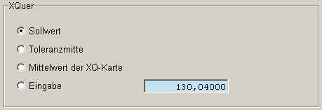
Editable/extensible:
No / No
Additional parameters:
None
Corresponding fields:

Status type: BEWART_MERK evaluation types of characteristics
Default entries:
Status | System status | Short description of status | Long description of status | Inactive | Addition
CODE | 1 | Code | acc. to ID code | 0
FEHLER_NC | 1 | n-c defect | Number of defects (n-c) | 0
FEST | 1 | not fixed | not fixed | 0 | [INIT]
FHL_EINH_NC | 1 | non-conforming units n-c | non-conforming units (n-c) | 0
MANUELL | 1 | manual | manual evaluation | 0
MW_TOLERANZ | 1 | XQ tolerance | Mean value in tolerance range | 0
REGLK | 1 | Control chart | Action limits of  control charts | 0
STICHPR | 1 | Samples | on sample level | 0
S_METHODE | 1 | s method | s method (ISO 3951) | 0
Description:
Intra-system status
Editable/extensible:
Yes / No
Additional parameters:
[INIT] Initial default assignment
Corresponding fields:

Status type: BEWART_SP – evaluation types of samples
Default entries:
Status | System status | Short description of status | Long description of status | Inactive | Addition
CODE | 1 | Code | acc. to ID code | 0
FEHLER_NC | 1 | n-c defect | Number of defects (n-c) | 0
FEST | 1 | not fixed | not fixed | 0 | [INIT]
FHL_EINH_NC | 1 | non-conforming units n-c | non-conforming units (n-c) | 0
MANUELL | 1 | manual | manual evaluation | 0
MW_TOLERANZ | 1 | XQ tolerance | Mean value in tolerance range | 0
REGLK | 1 | Control chart | Action limits of a control chart | 0
S_METHODE | 1 | s method | s method (ISO 3951) | 0
Description:
Intra-system status
Editable/extensible:
Yes / No
Additional parameters:
[INIT] Initial default assignment
Corresponding fields:

Status type: BEWELEMPROG – assessment programs for elements
Default entries:
Status | System status | Short description of status | Long description of status | Inactive | Addition
AUDIT_ERGEBNIS | 1 | Audit | Result of auditing | 0
LIEFERUNG_MENGE | 1 | Delivery quantity | Delivery quantity | 0
LIEFERUNG_TERMIN | 1 | Delivery date | Delivery date | 0
REKLAMATION_ANTEIL | 1 | Share of compl. | Share of complaints | 0
VDA_1 | 1 | VDA 1 | VDA procedure 1 | 0
VDA_2 | 1 | VDA 2 | VDA procedure 2 | 0
VDA_3 | 1 | VDA 3 | VDA procedure 3 | 0
WARENEINGANG_PENTSCHEID | 1 | Usage dec. | Usage decision | 0

Description:
Intra-system statuses:
These statuses define automatic classification for supplier evaluation. If an evaluation criterion is configured to "automatic determination" then the defined programs can be selected.
Further details: see the documentation dealing with evaluation and classification programs
Editable/extensible:
No / No
Additional parameters:
None
Corresponding fields:

Status type: BEWELEMQUELLE – source for the evaluation of elements
Default entries:
Status | System status | Short description of status | Long description of status | Inactive | Addition
EINGABE | 1 | Input | Manual input | 0 | [INIT]
PROGRAMM | 1 | autom. determ. | automatic determination | 0
Description:
Intra-system status
These statuses specify the source for the classification of the evaluation criteria. This is used when entering of evaluation catalogs in the console.
Editable/extensible:
No / No
Additional parameters:
[INIT] initialization value when creating a new evaluation criterion
Corresponding fields:

Status type: BEWSTATUS – evaluation type
Default entries:
Status | System  status | Short description of status | Long description of status | Inactive | Addition
ABGESCHL | 0 | compl. | completed | 0 | [ABG],[AUSW]
BEARB | 0 | in proc. | in process | 0 | [INIT:EINGABE_TEIL],[OFFEN]
BEWERTBAR | 0 | assessable | assessable | 0 | [INIT:EINGABE_ALLE],[OFFEN]
BEWERTET | 0 | evaluated | evaluated | 0 | [AUSW],[INIT:BEWERTET]
ERZEUGT | 0 | generated | generated | 0 | [INIT],[INIT:EINGABE_KEINS],[OFFEN]

Description:
Status of supplier evaluations
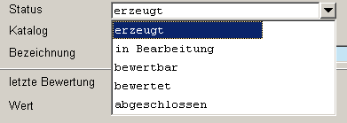
Editable/extensible:
Yes / Yes
Additional parameters:
[ABG] for flexibility and evaluation reasons, this flag is used internally when testing the status of the evaluation.
[AUSW] Statuses indicating which evaluations are to be integrated (with which status) in the supplier evaluation and comparison
[INIT] Initial default assignment when creating supplier evaluations
[INIT:BEWERTET] identifies the status that is assigned when an outstanding supplier evaluation has been evaluated.
[INIT:EINGABE_ALLE] identifies the status that is assigned when all catalog elements have been evaluated
[INIT_EINGABE_KEINS] identifies the status that is assigned when no catalog element has been evaluated yet.
[INIT:EINGABE_TEIL] identifies the status that is assigned when a part of the catalog elements but not all has been evaluated
[OFFEN] identifies supplier evaluations that are considered being open (irrespective of the evaluation)
Corresponding fields:

Status type: BEWTYP – Evaluation types
Default entries:
Status | System status | Short description of status | Long description of status | Inactive | Addition
AUTO | 0 | autom. gen. | automatically generated | 0 | [INIT:AUTO]
MANUELL | 0 | manual. gen. | manually generated | 0 | [INIT]
Description:
See documentation: "D:\doku\CAQ7.2\Handbücher CAQ\intern\lieferantenbewertung\hydra_caq_lfb_einstufung_bewertung.doc"
Editable/extensible:
Additional parameters:
[INIT] Initial default assignment
[INIT:AUTO]
Corresponding fields:
Example:

Status type: CAQ_TABELLEN – CAQ tables
Default entries:
CAQ tables with respective control parameters.
Description:
Control parameters for form management. They must not be changed by consultants/users.
Editable/extensible:
No / No
Additional parameters:
[FORMULAR] identifies tables from which printing is possible, e.g. caq_pplkop in contrast to caq_paumwert
[df] in general all filtered data records can be printed, e.g. confirmation of receipt of complaint
[dm] in general only the selected data record can be printed, e.g. initial sample forms
[oA2D] the archiving function for the form that has just been printed can be used
Corresponding fields:

Status type: CPLFREIGABE – List item of released control plans
Default entries:
Status | System status | Short description of status | Long description of status | Inactive | Addition
1 | 1 | Manufacturer/ site | Manufacturer/ site | 0
2 | 1 | Customer | Customer | 0
3 | 1 | Customer development | Customer development | 0
4 | 1 | Customer quality | Customer quality | 0
5 | 1 | other | other | 0
Description:
List item of released CPL. Status descriptions can be created and/or changed as part of customizing.
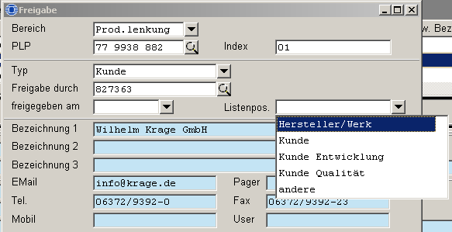
Editable/extensible:
Yes / Yes
Additional parameters:
None
Corresponding fields:

Status type: DEVICETYP – Device types
Default entries:
Status | System status | Short description of status | Long description of status | Inactive | Addition
KONSOLE | 1 | Console | HYDRA console | 0
MASCHINE | 1 | Mach. | Machine | 0
PDA | 1 | Mobile | Mobile device | 0
SPCM | 1 | SPCM | SPCM workstation | 1
Description:
Specifies the device types for logging on inspection orders
PDA and SPCM are currently not supported
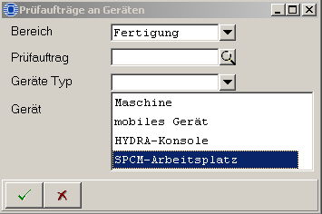
Editable/extensible:
No / No
Additional parameters:
None
Corresponding fields:

Status type: DOKTYP – Document types
Default entries:
Status | System status | Short description of status | Long description of status | Inactive | Addition
DATEI | 1 | File | File | 0
TEXT | 1 | Text | Text | 0
URL | 1 | URL | URL | 0
Description:
Possible document types (CAQ_DOKUS table)
Editable/extensible:
No / No
Additional parameters:
None
Corresponding fields:

Status type: DOKUPFLICHT – Status of required documentation
Default entries:
Status | System status | Short description of status | Long description of status | Inactive | Addition
0 | 1 | optional | optional | 0 | [INIT]
1 | 1 | always | always | 0
2 | 1 | fail | if fail | 0
3 | 1 | pass | if pass | 0

Description:
The status is queried in the script "b_ckat.hsc" when creating QMS catalogs.
CTK → What's the meaning of "documentation required"?
Editable/extensible:
Yes / No
Additional parameters:
[INIT] Initial default assignment if nothing is entered??? →CTK
Corresponding fields:

Status type: DYNART – Dynamic modification types
Default entries:
Status | System status | Short description of status | Long description of status | Inactive | Addition
KEINE | 1 | None | None | 0 | [INIT]
LOS | 1 | batch-rel. | batch-related | 0
MERKMAL | 1 | characteristic-rel. | characteristic-related | 0
MERKMAL_PPUNKT | 1 | Insp. pt. | Inspection point | 1
STICHPROBE | 0 | Sample | Sample-related | 1
Description:
Defines the possible types of dynamic modification stored in inspection plans and/or inspection plan characteristics as well as in inspection requirements and inspection order characteristics. Subject to the dynamic modification type, the dynamic modification history is also drawn up from inspection requirements and linked tables.
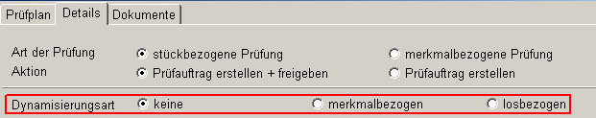
Editable/extensible:
No / No
Additional parameters:
[INIT] Initial default assignment when creating inspection plans
Corresponding fields:

Status type: DYN_SP_DATEN_BASIS – Data base for dynamic modification relating to samples
Default entries:
Status | System status | Short description of status | Long description of status | Inactive | Addition
AUTO_FA | 0 | aut. defect | automatic defect type | 0
PRFERG_SP | 0 | Insp. result | Inspection result | 0

Description:
Specifies on which basis dynamic modification relating to samples is performed, either based on the inspection result or on automatically generated defects. Properly interpreted???? --> CAC
Also see the document and/or detailed planning for WILDEN (delivery level x)
Editable/extensible:
Yes / Yes
Additional parameters:
None
Corresponding fields:

Status type: DYN_STPRANW_TYP – Types of sampling plans
Default entries:
Status | System status | Short description of status | Long description of status | Inactive | Addition
K | 1 | n-k-s | n-k + skip lot | 0 | [PRFTYP:V]
NC | 1 | n-c-d-s | n-c-d + Skip lot | 0 | [PRFTYP:A],[PRFTYP:V]
Description:
Status for the sampling plan type and/or selection options of a sampling plan type subject to the characteristic type (variable or attributive). The additional parameters enable the assignment and/or selection option.
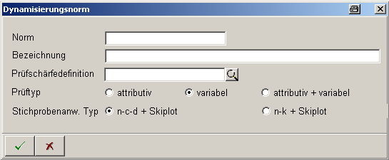
Editable/extensible:
No / No
Additional parameters:
[PRFTYP:V] This type of the sampling plan is available for variable characteristics
[PRFTYP:A] This type of the sampling plan is available for attributive characteristics

Corresponding fields:

Status type: EGWEINS – Action probability for unilateral distribution
Default entries:
Status | System status | Short description of status | Long description of status | Inactive | Addition
1 | 1 | 84.1345% (1 Sigma) | 84.1345% (1 Sigma) | 0
1.28 | 1 | 90% (1.28 Sigma) | 90% (1.28 Sigma) | 0
1.64 | 1 | 95% (1.64 Sigma) | 95% (1.64 Sigma) | 0
1.96 | 1 | 97.5% (1.96 Sigma) | 97.5% (1.96 Sigma) | 0
2 | 1 | 97.725% (2 Sigma) | 97.725% (2 Sigma) | 0
2.33 | 1 | 99% (2.33 Sigma) | 99% (2.33 Sigma) | 0
2.58 | 1 | 99.5% (2.58 Sigma) | 99.5% (2.58 Sigma) | 0
3 | 1 | 99.865% (3 Sigma) | 99.865% (3 Sigma) | 0
3.09 | 1 | 99.9% (3.09 Sigma) | 99.9% (3.09 Sigma) | 0
3.72 | 1 | 99.99% (3.72 Sigma) | 99.99% (3.72 Sigma) | 0
4 | 1 | 99.9968% (4 Sigma) | 99.9968% (4 Sigma) | 0
Description:
Selection options and/or calculation values for sigma to compute unilateral limit values (warning and action limits). It is not allowed to add further entries during customizing!
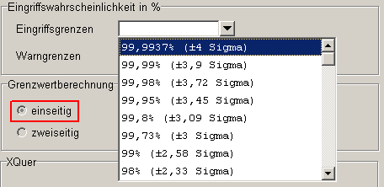
Editable/extensible:
No / No
Additional parameters:
None
Corresponding fields:

Status type: EGWZWEI – Action probability for bilateral distribution
Default entries:
Status | System status | Short description of status | Long description of status | Inactive | Addition
1 | 1 | 68.27% (±1 Sigma) | 68.27% (±1 Sigma) | 0
1.28 | 1 | 80% (±1.28 Sigma) | 80% (±1.28 Sigma) | 0
1.64 | 1 | 90% (±1.64 Sigma) | 90% (±1.64 Sigma) | 0
1.96 | 1 | 95% (±1.96 Sigma) | 95% (±1.96 Sigma) | 0
2 | 1 | 95.45% (±2 Sigma) | 95.45% (±2 Sigma) | 0
2.28 | 1 | 97.5% (±2.28 Sigma) | 97.5% (±2.28 Sigma) | 0
2.33 | 1 | 98% (±2.33 Sigma) | 98% (±2.33 Sigma) | 0
2.58 | 1 | 99% (±2.58 Sigma) | 99% (±2.58 Sigma) | 0
3 | 1 | 99.73% (±3 Sigma) | 99.73% (±3 Sigma) | 0
3.09 | 1 | 99.8% (±3.09 Sigma) | 99.8% (±3.09 Sigma) | 0
3.45 | 1 | 99.95% (±3.45 Sigma) | 99.95% (±3.45 Sigma) | 0
3.72 | 1 | 99.98% (±3.72 Sigma) | 99.98% (±3.72 Sigma) | 0
3.9 | 1 | 99.99% (±3.9 Sigma) | 99.99% (±3.9 Sigma) | 0
4 | 1 | 99.9937% (±4 Sigma) | 99.9937% (±4 Sigma) | 0
Description:
Selection options and/or calculation values for sigma to compute bilateral limit values (warning and action limits). It is not allowed to add further entries during customizing!
Editable/extensible:
No / No
Additional parameters:
None
Corresponding fields:

Status type: EGWZWEI_RS – Action probability for bilateral distribution (r and s chart)
Default entries:
Status | System status | Short description of status | Long description of status | Inactive | Addition
0.9 | 1 | 90% | 90% | 0
0.95 | 1 | 95% | 95% | 0
0.975 | 1 | 97.5% | 97.5% | 0
0.99 | 1 | 99% | 99% | 0
0.995 | 1 | 99.5% | 99.5% | 0
Description:
Selection options and/or calculation values for sigma to compute bilateral limit values (warning and action limits) for the r and s chart. It is not allowed to add further entries during customizing.
Editable/extensible:
No / No
Additional parameters:
None
Corresponding fields:

Status type: EMUFORM – Initial sample forms
Default entries:
Status | System status | Short description of status | Long description of status | Inactive | Addition
 | 0 | not assigned | not assigned | 0
PPAP | 0 | PPAP | PPAP | 0
VDA22 | 0 | VDA 2/2 | VDA volume 2, 2nd edition. | 0
VDA23 | 0 | VDA 2/3 | VDA volume 2, 3rd edition | 0
Description:
Selection options and/or assignment of initial sampling forms. The assignment determines which fields are shown and/or hidden in inspection plan characteristics.
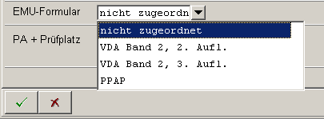
Editable/extensible:
Yes / Yes
Additional parameters:
None
Corresponding fields:

Status type: EMUMMTYP_PPAP – EMU Assignment of characteristics according to PPAP EMUMMTYP_PPAP
Default entries:
Status | System status | Short description of status | Long description of status | Inactive | Addition
 | 0 | not assigned | not assigned | 0
DIMENSION | 0 | Dimensions | Dimensions | 0 | [FILTER:CPK]
ERSCHEINUNG | 0 | Appearance | Appearance | 0
MATERIAL_FUNKTION | 0 | Mat./Funct. | Material/Function | 0
Description:
Depending on the status of the EMUFORM status type, possible assignments are made in the EMUMMTYP_PPAP status type. The selection made can be printed in the form.
Editable/extensible:
Yes / Yes
Additional parameters:
[FILTER:CPK] ???
Corresponding fields:

Status type: EMUMMTYP_VDA22 – Initial sampling assignment of characteristics VDA volume 2, 2nd edition
Default entries:
Status | System status | Short description of status | Long description of status | Inactive | Addition
 | 0 | not assigned | not assigned | 0
ATTRIBUTIV | 0 | Attributive | Attributive inspection | 0
FUNKTION | 0 | Function | Function test | 0
MASS | 0 | Measure | Size check | 0 | [FILTER:CPK]
SICHT | 0 | Visual | Visual inspection | 0
WERKSTOFF | 0 | Material | Material testing | 0
ZUVERLAESSIG | 0 | Reliability | Reliability test | 0
Description:
Depending on the status of the EMUFORM status type, possible assignments are made in the EMUMMTYP_VDA22 status type. The selection made can be printed on the form.
Editable/extensible:
Yes / Yes
Additional parameters:
[FILTER:CPK] CJD
Corresponding fields:

Status type: EMUMMTYP_VDA23 – Initial sampling assignment of characteristics VDA volume 2, 3rd edition
Default entries:
Status | System  status | Status  Short name | Long description of status | In-  active | Addition
 | 0 | not assigned | not assigned | 0
AKUSTIK | 0 | Acoustics | Acoustics | 0
DATENSICHERHEIT | 0 | EC data  security | EC data security  sheet | 0
ERSCHEINUNG | 0 | Appearance | Appearance | 0
FUNKTION | 0 | Function | Function test | 0
GERUCH | 0 | Scent | Scent | 0
HAPTIK | 0 | Haptics | Haptics | 0
INHALTSSTOFFE | 0 | Ingredients | Ingredients in  purchased parts | 1 | [FILTER:INHALTSTOFFE]
MASS | 0 | Measure | Size check | 0
PROZESSABLAUF | 0 | Process flow | Process flow-  diagram | 0
PROZESSFAEHIG | 0 | Process capability | Verification of  process capability | 0 | [FILTER:CPK]
PRUEFMITTELFAEHIGKEIT | 0 | Test equipment  capability | Verification of test equipment-  capability | 0
PRUEFMITTELLISTE | 0 | List of test equipment (gages) | List of test equipment (gages) | 0
SONSTIGES | 0 | All | All | 0
WERKSTOFF | 0 | Material | Material testing | 0
ZUVERLAESSIG | 0 | Reliability | Reliability-  test | 0
Description:
Depending on the status of the EMUFORM status type, possible assignments are made in the EMUMMTYP_VDA23 status type. The selection made can be printed on the form.
Editable/extensible:
No / No
Additional parameters:
[FILTER:INHALTSSTOFFE] ???
[FILTER:CPK] ???
Corresponding fields:

Status type: ERFART – Input types
Default entries:
Status | System status | Short description of status | Long description of status | Inactive | Addition
AUTOMAT | 1 | automat. | automatic collection | 0
MANUELL | 1 | manual | manual collection | 0
Description:
Status for the input type. Automatic collection is to be selected for PDV. A process parameter connected with a logical channel is to be defined for the characteristic.
Editable/extensible:
No / No
Additional parameters:
None
Corresponding fields:

Status type: ERFASSART – Input types
Default entries:
Status | Status  Short name | Long description of status | Addition
BEWERT_ESTCK | Single unit  eval. | Single unit  evaluation | [DYNDLG:Q_MW_B_EST],  [BAPI:CPAUMW],[M_MAX:1]
BEWERT_ESTCK_PPUNKT | Single unit.  evaluation of insp. point | Single unit evaluation  of an inspection point | [DYNDLG:Q_MW_B_EST],  [BAPI:CPAUMW],[M_MAX_NUM:1]
BEWERT_ESTCK_STICHPR | Single unit.  eval. of sample | Single unit evaluation  of a sample | [DYNDLG:Q_MW_B_EST],  BAPI:CPAUMW]
BEWERT_MERK | Eval. of  charact. | Evaluation of a characteristic | [DYNDLG:Q_MW_B_MER],  [BAPI:CPAUSP],[M_MAX:1]
BEWERT_STICHPR | Eval.  sample | Evaluation of a sample | [INIT_A],[DYNDLG:Q_MW_B_STP],  [BAPI:CPAUSP]
BEWERT_STICHPR_PPUNKT | Sample eval.  of insp. point. | Sample evaluation  of an inspection point | [DYNDLG:Q_MW_B_MER],  [BAPI:CPAUSP],[M_MAX_NUM:1]
CODE_ESTCK | Single unit  code | Single unit code | [DYNDLG:Q_MW_C_EST],  [BAPI:CPAUMW],[M_MAX:1]
CODE_ESTCK_PPUNKT | Single unit  code insp. pt. | Single unit code of an  inspection point | [DYNDLG:Q_MW_C_EST],  [BAPI:CPAUMW],[M_MAX_NUM:1]
CODE_ESTCK_STICHPR | Single unit  code sample | Single unit code of a  sample | [INIT_V],[DYNDLG:Q_MW_C_EST],  [BAPI:CPAUMW]
CODE_MERK | Code  charact. | Characteristic code | [DYNDLG:Q_MW_C_MER],  [BAPI:CPAUSP],[M_MAX:1]
CODE_STICHPR | Code  sample | Sample code | [DYNDLG:Q_MW_C_STP],  [BAPI:CPAUSP]
CODE_STICHPR_PPUNKT | Samp.code  insp.p. | Sample code of an  inspection point | [DYNDLG:Q_MW_C_MER],  [BAPI:CPAUSP],[M_MAX_NUM:1]
MESSW_ESTCK | Meas. val.  single unit | Measured value of single unit | [DYNDLG:Q_MW_M_EST],  [BAPI:CPAUMW],[M_MAX:1],  [HIST]
MESSW_ESTCK_PPUNKT | Meas.val.  sing.unit insp.p. | Measured value of single units of an inspection point | [DYNDLG:Q_MW_M_EST],  [BAPI:CPAUMW],[M_MAX_NUM:1],  [HIST]
MESSW_ESTCK_STICHPR | Meas.val.  sing.unit samp. | Measured value of single unit of a sample | [DYNDLG:Q_MW_M_EST],  [BAPI:CPAUMW],[HIST]
MESSW_MERK | Meas.val.  charac. | Measured value of characteristic | [DYNDLG:Q_MW_M_MER],  [BAPI:CPAUSP],[M_MAX:1]
MESSW_STICHPR | Meas.val.  samp. | Measured value of sample | [DYNDLG:Q_MW_M_STP],  [BAPI:CPAUSP]
MESSW_STICHPR_PPUNKT | Meas.val.  samp.insp.p. | Measured value of sample of an inspection point | [DYNDLG:Q_MW_M_MER],  [BAPI:CPAUSP],  [M_MAX_NUM:1]
Description:
Status to define and structure QMS dialogs on the terminal.
Editable/extensible:
Yes / No
Additional parameters:
[DYNDLG:Q_MW_B_EST] Dialog to evaluate the single unit
[DYNDLG:Q_MW_B_MER] Dialog to evaluate the single unit of an inspection point
[DYNDLG:Q_MW_B_STP] Dialog to evaluate the single unit of a sample
[DYNDLG:Q_MW_C_EST] Dialog to enter the code of the single unit
[DYNDLG:Q_MW_C_MER] Dialog to enter the code of the inspection point
[DYNDLG:Q_MW_C_STP] Dialog to enter the code of the sample
[DYNDLG:Q_MW_M_EST] Dialog to enter measured values for the single unit
[DYNDLG:Q_MW_M_MER] Dialog to enter measured values for the inspection point
[DYNDLG:Q_MW_M_STP] Dialog to enter measured values for the sample
[BAPI:CPAUMW] BAPI for single units
[BAPI:CPAUSP] BAPI for samples and inspection points
[M_MAX:1] ???
[M_MAX_NUM:1] ???
[INIT_A] ???
[HIST] ???
Corresponding fields:
Please note:
Only relevant in connection with QMS.

Status type: ERFINT – Types of collection intervals
Default entries:
Status | System status | Short description of status | Long description of status | Inactive | Addition
EINMAL | 1 | one-time | one-time | 0
KEINS | 1 | none | none | 0
MATRIX | 1 | Matrix | Inspection matrix | 1
STCK | 1 | Piece | Piece-related | 0
ZEIT | 1 | Time | Time-related | 0

Description:
Interval types that can be chosen for the characteristic (sampling scheme):
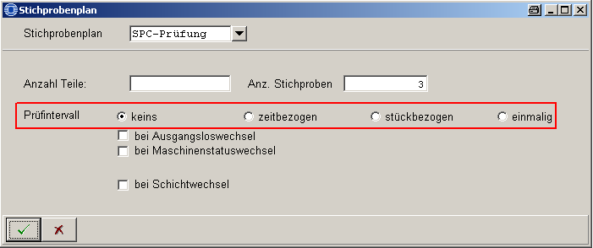
Editable/extensible:
No / No
Additional parameters:
None
Corresponding fields:

Status type: FEHLER_KLASSE – Defect classes
Default entries:
Status | System status | Short description of status | Long description of status | Inactive | Addition
 | 0 |  |  | 0 | [INIT],[IFCRCK:]
01 | 0 | Critical | Critical defect | 0 | [IFCRCK:01]
02 | 0 | Major def. A | Major defect A | 0 | [IFCRCK:02],[INIT_V]
03 | 0 | Major def. B | Major defect B | 0 | [IFCRCK:03]
04 | 0 | Min. def. A | Minor defect A | 0 | [IFCRCK:04]
05 | 0 | Min. def. B | Minor defect B | 0 | [IFCRCK:05]
A1 | 0 | QM def.  prov. | Defined in the QM system  proven | 0 | [IFCRCK:A1]
A2 | 0 | not def.  proven | Not defined  proven | 0 | [IFCRCK:A2]
A3 | 0 | def. main.  proven | Defined, mainly  proven | 0 | [IFCRCK:A3]
A4 | 0 | not def., main.  proven | Not defined, mainly  proven | 0 | [IFCRCK:A4]
A5 | 0 | not prov. | Not proven | 0 | [IFCRCK:A5]
Description:
The statuses define the possible QMS defect classes. By default, all defect classes available in SAP are included.
Editable/extensible:
Yes / Yes
Additional parameters:
[IFCRCK:<Status>] controls which data value is returned to SAP via the QM-IDI interface for the respective defect class.
[INIT_V] Statuses with this parameter are suggested in certain QMS input dialogs when defects occur in variable characteristics.
[INIT] currently impossible to define whether or not this parameter is functioning. Has to be checked by SWD
Corresponding fields:

Status type: FHLANTYP – Failure analysis criteria
Default entries:
Status | System status | Short description of status | Long description of status | Inactive | Addition
FA | 0 | Def. type | Defect type | 0 | [F]
FO | 0 | Def. loc. | Defect location | 0 | [F]
FU | 0 | Def. cause | Defect cause | 0 | [F]
QMS_FE | 1 | QMS defects | QMS defects | 1
VU | 0 | Cause | Causer/party responsible | 0
Description:
Defect types that can be recorded and evaluated.
Editable/extensible:
Yes / Yes
Additional parameters:
[F] What does this parameter mean exactly? Where is it queried?
Corresponding fields:

Status type: FHLBEW_EINHEIT – Units of defect evaluation
Default entries:
Status | System status | Short description of status | Long description of status | Inactive | Addition
 | 0 |  |  | 0 | [INIT]
EUR | 0 | Euro | Euro | 0
MIN | 0 | Min. | Minutes | 0
Description:
These statuses are available for the QMS defects recording to evaluate defects.
When using HYDRA-QMS, these status entries must possibly be adapted to the units available in SAP to evaluate defects.
Please note!!
The upload interface for QM-IDI defects only provides space for three characters. Therefore, only the first three characters of the corresponding status ID are used for uploads/confirmation via QM-IDI.
Editable/extensible:
Yes / Yes
Additional parameters:
[INIT] This parameter is currently not functioning.
Corresponding fields:

Status type: FHLGEW – Defect weighting
Default entries:
Status | System status | Short description of status | Long description of status | Inactive | Addition
HAUPT | 1 | Major | Major defect | 0
KRIT | 1 | Critical | Critical defect | 0
NEBEN | 1 | Minor | Minor defect | 0
Description:
Statuses for defects weighting in characteristics.
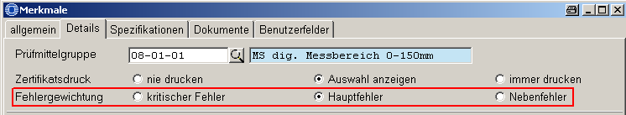
Editable/extensible:
No / No
Additional parameters:
None
Corresponding fields:

Status type: FIRMENTYP – Company type
Default entries:
Status | System status | Short description of status | Long description of status | Inactive | Addition
HERSTELLER | 1 | Manufacturer | Manufacturer | 0
INTERN | 0 | internal | internal | 0
KUNDE | 1 | Customer | Customer | 0
LIEFERANT | 1 | Supplier | Supplier | 0
Description:
Available company types to create companies. In theory, new statuses can be created while customizing the system.
Editable/extensible:
Yes / Yes
Additional parameters:
None
Corresponding fields:

Status type: FORMULARTYP – Form types (for printing)
Default entries:
Status | System  status | Status  Short name | Status  Long name | In-  active | Addition
CHART | 1 | Diagram | Output of a  diagram | 0 | [zB],[zP],[z_E],[zD],[dF],  [oAr],[oA2D]
EXCEL | 1 | Excel | Excel for Windows | 0 | [zB],[zP],[zE],[zD],[dM],[dF],  [oK],[oVS],[oBS],[oAr],[oA2D]
GANTT | 1 | Gantt | Output of a  Gantt diagram | 0 | [zB],[zP],[zE],[zD],[dF],[oAr],  [oA2D]
QUICKREPORT | 1 | Report | HYDRA report | 0 | [zB],[zP],[zD],[zR],[dM],[dF],  [dA],[oK],[oVS],[oBS]
TABELLE | 1 | Table | Table | 0 | [zB],[zP],[dF]
TABELLE_DATEI_HTML | 1 | Table (HTML) | Table  (HTML format) | 0 | [zB],[zP],[zE],[zD],[dM],[dF],  [oAr],[oA2D]
TABELLE_DATEI_TXT | 1 | Table (TXT) | Table  (text format) | 0 | [zB],[zP],[zE],[zD],[dM],[dF],  [oAr],[oA2D]
TABELLE_DATEI_XLS | 1 | Table (XLS) | Table  (Excel format) | 0 | [zB],[zP],[zE],[zD],[dM],[dF],  [oAr],[oA2D]
WINWORD | 1 | Word | Word for Windows | 0 | [zB],[zP],[zE],[zD],[dM],[dF],  [oK],[oVS],[oBS],[oAr],[oA2D]
Description:
The statuses define the different form types available in HYDRA-CAQ.
Editable/extensible:
No / No
Additional parameters:
[df] In general all filtered data records can be printed, e.g. confirmation of receipt of complaint (relating to this form type)
[dm] In general only the selected data record can be printed, e.g. initial sampling form (relating to this form type)
[oA2D] The archiving function for the form that has just been printed can be used (relating to this form type)
[oK] The checkbox "number of copies" is displayed while printing and the content is forwarded to the form
[oVS] The "from page" field is shown and the content is forwarded to the form
[oBS] The "to page" field is shown and the content is forwarded to the form
[oAr] The checkbox "archive" is displayed and the content is forwarded to the form
[zB] The radio button "where to print ... " includes the print destination "screen"
[zP] The radio button "where to print ..." includes the print destination "printer"
[zE] The radio button "where to print ... includes the print destination "e-mail"
[zD] The radio button "where to print ..." includes the print destination "file"
Corresponding fields:

Status type: INTERVAL – Intervals
Default entries:
Status | System status | Short description of status | Long description of status | Inactive | Addition
JAH | 1 | Year(s) | Year(s) | 0 | 31557600
MIN | 1 | Minute(s) | Minute(s) | 0 | 60
MON | 1 | Month(s) | Month(s) | 0 | 2629800
SEK | 1 | Second(s) | Second(s) | 0 | 1
STD | 1 | Hour(s) | Hour(s) | 0 | 3600
TAG | 1 | Day(s) | Day(s) | 0 | 86400
Description:
Defines the interval units based on which calculations are made in HYDRA. This affects, for example, the calculation of due dates for test equipment depending on the last calibration and/or maintenance. --> where are the interval types sec, min, hrs required?
Example: work plan (PMV):
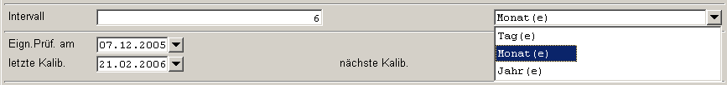
Editable/extensible:
No / No
Additional parameters:
[31557600] Year in seconds
[60] Minute in seconds
[2629800] Month in seconds
[1] One second
[3600] Hour in seconds
[86400] Day in seconds
Corresponding fields:

Status type: KAT_BEWERTUNG – Catalog evaluations
Default entries:
Status | System status | Short description of status | Long description of status | Inactive | Addition
IO | 1 | pass | pass | 0 | [IO]
NIO | 1 | fail | fail | 0 | [NIO]
OFFEN | 1 | open | open | 0 | [INIT]
Description:
Evaluation status of QMS catalogs → additional information?
Editable/extensible:
Yes / No
Additional parameters:
[IO] Identifies the status for "pass" decisions
[NIO] Identifies the status for "fail" decisions
[INIT] Initial status
Corresponding fields:

Status type: KSTTYP – Cost types
Default entries:
Status | System status | Short description of status | Long description of status | Inactive | Addition
PAU | 1 | Inspection order | Inspection order | 0
REK | 1 | Complaint | Complaint | 0
Description:
The cost type is only used for the filter combo box "valid for" in the cost types dialog and refers to the database field "gueltig_flags" of the caq_kostenart table.
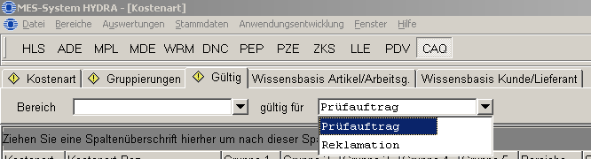
Editable/extensible:
No / No
Additional parameters:
None
Please note:
The "gueltig_flags" field cannot be filled out via the dialog and is always empty by default.
Corresponding fields:
caq_kostenart.gueltig_flags

Status type: MASSANGABE – Type of measurement
Default entries:
Status | System status | Short description of status | Long description of status | Inactive | Addition
ABSOLUT | 0 | abs. | absolute | 0 | [INIT]
PROZENTUAL | 0 | perc. | percentage | 0
RELATIV | 0 | rel. | relative | 0
Description:
Defines how limit values are indicated in characteristic specifications. "Absolute" is assigned by default.
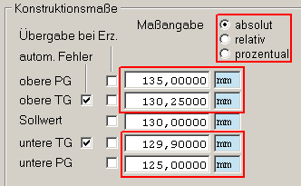
Editable/extensible:
No / No
Additional parameters:
[INIT] Initial default assignment when a new characteristic is created in the characteristics master data catalog
Corresponding fields:

Status type: MASSNTYP – Measure types
Default entries:
Status | System status | Short description of status | Long description of status | Inactive | Addition
KEINE | 0 | no assignm. | no assignment | 0 | [INIT],[RECTYPE:REK]
KURZF | 0 | Short-term | Short-term | 0 | [RECTYPE:REK]
LANGF | 0 | Long-term | Long-term | 0 | [RECTYPE:REK]
MITTELF | 0 | Medium-term | Medium-term | 0 | [RECTYPE:REK]
Description:
The statuses define the possible types of measures. --> Is it also possible to define and enter possible measure types for e.g. FEP; WEP etc. at terminal and console?
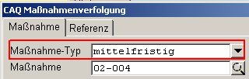
Editable/extensible:
Yes / Yes
Additional parameters:
[INIT] Initial default assignment when creating a measure (caq_massn)
[RECTYPE:REK] Measure type is available in complaints management
Corresponding fields:

Status type: MASSTATUS – Measure status
Default entries:
Status | System  status | Status  Short name | Status  Long name | Inactive | Addition
BEARB | 0 | in process | in process | 0 | [BEARB],[BGC:65535],[FGC:0],  [NUMWERT:50],[OUTLSTAT:1,4,3]
ERLEDIGT | 0 | completed | completed | 0 | [FERTIG],[INIT:FERTIG],[BGC:65280],  [FGC:0],NUMWERT:100],[OUTLSTAT:2]
OFFEN | 0 | open | open | 0 | [INIT],[OFFEN],[BGC:255],  [FGC:0],[NUMWERT:0],[OUTLSTAT:0]
SICHT | 0 | sifted/read | sifted/read | 0 | [OFFEN],[BGC:255],[FGC:0],  [NUMWERT:0],[OUTLSTAT:0]

Description:
Status entries for the possible statuses of a measure.
Editable/extensible:
Yes / Yes
Additional parameters:
[INIT] Initial default assignment when creating a measure
[BEARB] CBE: waiting for response by CTK
[BGC:65535]
[BGC:65280]
[BGC:255]
[FGC:0]
[NUMWERT:50]
[NUMWERT:0]
[NUMWERT:100]
[OUTLSTAT:1,4,3]
[OUTLSTAT:0]
[OUTLSTAT:2]
[FERTIG]
[INIT:FERTIG]
[OFFEN]
Corresponding fields:

Status type: MDIKONFANSCHL – Types of MDI connections
Default entries:
Status | System status | Short description of status | Long description of status | Inactive | Addition
FEST | 1 | fixed | fixed | 0
KEINER | 1 | None | None | 0 | [INIT]
VARIABEL | 1 | Variable | Variable | 0
Description:
The status entries specify the connection types of the MDI channel for test equipment or test equipment groups. If "variable" is selected, the channels for the test equipment/test equipment groups are to be defined in the mdi.ini file at the terminal.
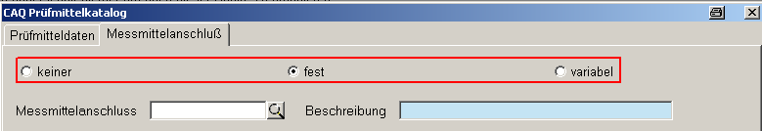
Editable/extensible:
No / No
Additional parameters:
[INIT] Initial default assignment when creating a test equipment/test equipment group
Corresponding fields:

Status type: MERKMAL_AKTION – Generation of inspection steps and characteristics
Default entries:
Status | System status | Short description of status | Long description of status | Inactive | Addition
AG_AN | 1 | When logging on OP | When OP is logged on | 0
PAN_CREATE | 1 | When generating insp. requ. | When generating inspection requirements | 0
Description:
CBE: waiting for response by CTK
Editable/extensible:
Yes / Yes
Additional parameters:
None
Corresponding fields:

Status type: MERKSTATUS – Characteristic status
Default entries:
Status | System status | Short description of status | Long description of status | Inactive | Addition
ERB | 1 | inherited | inherited | 0
ERG | 1 | Result | Result | 0 | [BGC:8454143],[FGC:0],[NUMWERT:100]
FHL | 1 | Defects | Defective | 0
GEP | 1 | Checked | Checked | 0
PRF | 1 | testable | testable | 0
SKL | 1 | Skip lot | Skip lot | 0
Description:
Status entries define the possible statuses of a characteristic. The "ERB" status is only used for specific customers. The "FHL" status is used for a characteristic, for example, if no entry is found in the specification list.
Editable/extensible:
No / No
Additional parameters:
[BGC:8454143] Waiting for response by CTK and/or CJD Background color
[FGC:0] Foreground color
[NUMWERT:100]
Corresponding fields:
Example:

Status type: MERKTYP – Characteristic types
Default entries:
Status | System status | Short description of status | Long description of status | Inactive | Addition
PRODUKT | 1 | Product | Product characteristic | 0
PROZESS | 1 | Process | Process characteristic | 0
Description:
Statuses define the characteristic types that are to be selected in the characteristic configuration: product and process characteristic:
Editable/extensible:
No / No
Additional parameters:
None
Corresponding fields:

Status type: MESS_ATTRIBUT – Attributes for recorded values
Default entries:
Status | System status | Short description of status | Long description of status | Inactive | Addition
 | 0 |  |  | 0 | [INIT],[IFCRCK:]
AUSSREISSER | 0 | * | Outlier | 0 | [IFCRCK:*]
GROESSER | 0 | > | greater | 0 | [IFCRCK:>]
KLEINER | 0 | < | Less | 0 | [IFCRCK:<]
SCHAETZWERT | 0 | ? | Estimated value | 0 | [IFCRCK:?]
Description:
Demand information from CTK
Editable/extensible:
Yes / Yes
Additional parameters:
[INIT] CTK
[IFCRCK:<value>] controls which data value is returned to SAP via the QM-IDI interface for the respective attribute.
Corresponding fields:

Status type: MMTYP – Types of measuring equipment
Default entries:
Status | System status | Short description of status | Long description of status | Inactive | Addition
MANUELL | 1 | manual | Manual input | 0
UMT | 1 | UMT | via UMT | 0
Description:
Status UMT is no longer used; has been replaced by MDI
Editable/extensible:
No / No
Additional parameters:
None
Corresponding fields:

Status type: MT_NORM – Standards for measuring tolerances
Default entries:
Status | System  status | Short description of status | Long description of status | Inactive | Addition
EN12420 | X | EN 12420 | DIN EN 12420  (drop forgings  of material group 1; cat. A and B) | X | [ID]
ISO2768 | X | ISO 2768 | General tolerances according to DIN ISO 2768
ISO7168 |  | ISO 7168 | Shape and position tolerance ISO 7168
ISO_PASS |  | ISO fit | ISO fit measures |  | [ID]
Description:
The statuses of the type MT_NORM include the standards that are available for the calculation of characteristic tolerances.
Editable/extensible:
Yes / Yes
Additional parameters:
[ID] Identifier indicating that for an unambiguous selection of an entry from the caq_passung table, the field passung_id is additionally required.
If this additional parameter is not set, it is sufficient to select the standard.
Please note!!
Some standards use texts to describe the fit ID (burr, misalignment, etc, e.g. with EN12420). Since fit IDs are not translated, users might get confused in case of multilingual installations. If necessary, this problem has to be solved in the software from case to case.

Status type: MUSSPRF – Status of mandatory inspections
Default entries:
Status | System status | Short description of status | Long description of status | Inactive | Addition
0 | 1 | optional | can be checked | 0 | [INIT]
1 | 1 | mandatory | must be checked | 0
2 | 1 | previous is "pass" | if previous is "pass" | 0
3 | 1 | previous is "fail" | if previous is "fail" | 0
Description:
Status 0 indicates that the characteristic does not have to be checked (sample) and the inspection order and/or inspection requirement can be completed. Status 1 defines that at least one sample has to be recorded for the characteristic.
Right interpretation??? Is it processed at all?
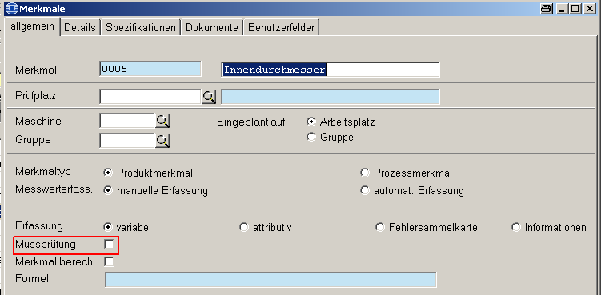
Editable/extensible:
No / No
Additional parameters:
[INIT] Initial default assignment when creating a characteristic in the master data catalog
Corresponding fields:

Status type: NESTZUORD – Options for cavity assignment
Default entries:
Status | System status | Short description of status | Long description of status | Inactive | Addition
KEINE | 1 | None | None | 0
MESSWERT | 1 | Measured value | Measured value | 0
STICHPROBE | 1 | Sample | Sample | 0
Description:
Specifies how cavities can be assigned to the recorded data (none, measured value, sample). This setting can be made in inspection plans.
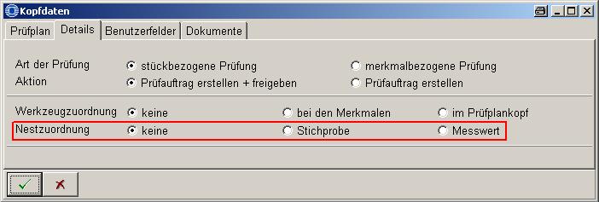
Editable/extensible:
No / No
Additional parameters:
None
Corresponding fields:

Status type: NUMMERTYP – Number types
Default entries:
Status | System status | Short description of status | Long description of status | Inactive | Addition
KUNDE | 0 | Customer no. | Customer number | 1 | [RECTYPE:FEP]
LAGER | 0 | Wareh. no. | Warehouse number | 0 | [RECTYPE:WEP]
PPUNKT | 0 | Insp. point | Inspection point | 0 | [RECTYPE:QMS]
PROBE | 0 | Sample | Sample | 0
PROTOKOLL | 0 | Prot. no. | Protocol number | 0 | [RECTYPE:FEP]
PRUEFLING | 0 | Unit to be insp. | Unit to be inspected | 0
SERIE | 0 | Serial no. | Serial number | 0 | [RECTYPE:FEP]
Description:
Statuses define the number entries that can be collected along with recording measured values and attributive decisions. In addition, number types are required when generating number pool entries. With the aid of the status PPUNKT inspection points are displayed in connection with QMS. The PROBE status is used within the system if sample-based measurement recording is in use.
See options 1071 and 1072 to enable number-based measurement recording and the number pool.
Editable/extensible:
Yes / Yes
Additional parameters:
[RECTYPE:<rec_type>] Defines the RECTYPE (module) for which the status (number) applies.
Corresponding fields:
Example:
Status | System status | Short description of status | Long description of status | Inactive | Addition
CHARGE | 0 | Batch no. | Batch number | 0 | [RECTYPE:FEP]
Option 1071 including the number type have to be created to record the batch number with measurement recording. It is also possible to enable it for a specific area (area-dependent).

Status type: NUMPOOLBEARBSTA – Processing status of number pool entries
Default entries:
Status | System status | Short description of status | Long description of status | Inactive | Addition
ABGESCHL | 0 | compl. | completed | 0 | [INIT:ABG]
OFFEN | 0 | open | open | 0 | [INIT]
Description:
Statuses define the possible processing statuses of number pool entries
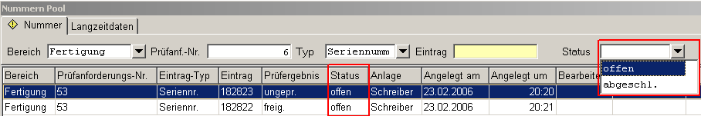
Editable/extensible:
No / No
Additional parameters:
[INIT:ABG] Identifies the status that is to be set for completed number entries.
[INIT] Identifies the initial status when creating a number pool entry
Corresponding fields:

Status type: NUMPOOLSTA – Status of the number pool
Default entries:
Status | System  status | Status  Short name | Status  Long name | In-  active | Addition
F | 0 | rel. | released | 0 | [NUMMERTYP:SERIE],[SP_PRFERG_INIT:IO],  [SP_PRFERG_INIT:BEDINGT_IO]
O | 0 | unch. | unchecked | 0 | [NUMMERTYP:SERIE],[INIT],  [SP_PRFERG_INIT:UNGEPR]
PPKT_IO | 0 | pass | pass | 0 | [NUMMERTYP:PPUNKT],[INIT],[SP_PRFERG_INIT:IO],  [SP_PRFERG_INIT:UNGEPR]
PPKT_NIO | 0 | fail | fail | 0 | [NUMMERTYP:PPUNKT],[SP_PRFERG_INIT:NIO]
PRB_IO | 0 | pass | pass | 0 | [NUMMERTYP:PROBE],[SP_PRFERG_INIT:IO]
PRB_NIO | 0 | fail | fail | 0 | [NUMMERTYP:PROBE],[SP_PRFERG_INIT:NIO]
PRB_UNGEPR | 0 | unch. | unchecked | 0 | [INIT],[NUMMERTYP:PROBE],  [SP_PRFERG_INIT:UNGEPR]
S | 0 | bl. | blocked | 0 | [NUMMERTYP:SERIE],[SP_PRFERG_INIT:NIO]
Description:
Number pool statuses set for a number entry subject to additional parameters
Editable/extensible:
Yes / Yes
Additional parameters:
[NUMMERNTYP:<STATUS>] Identifies for which number type (status type: NUMMERTYP) the number pool status applies
[INIT] Identifies the number pool status that is to be set when new number pool entries are set
[SP_PRFERG_INIT:NIO] Identifies the number pool status that is to be set if the inspection result of the sample is conditionally fail (status type: PRFERG_STPR).
[SP_PRFERG_INIT:BEDINGT_IO] Identifies the number pool status that is to be set if the inspection result of the sample is conditionally pass (status type: PRFERG_STPR).
[SP_PRFERG_INIT:IO] Identifies the number pool status that is to be set if the inspection result of the sample is "pass" (status type: PRFERG_STPR).
[SP_PRFERG_INIT:UNGEPR] Identifies the number pool status that is to be set if the inspection result of the sample is "pass" (status type: PRFERG_STPR).
Please note:
The worst result each of a sample of characteristics is used to set the number pool status. --> is this true?
Corresponding fields:

Status type: PANERG – Inspection request results
Default entries:
Status | System  status | Status  Short name | Status  Long name | In-  active | Addition
BEDINGT_IO | 1 | cond. pass | conditionally pass | 0 | [INIT:BEDINGT_IO],[BEDINGT_IO],[RECTYP:PMV]
IO | 1 | pass | pass | 0 | [INIT:IO],[IO],[INIT:SKL]
NIO | 1 | fail | fail | 0 | [INIT:NIO],[NIO]
Description:
Defines the statuses of inspection requirement results. They are set subject to the additional parameters.
Editable/extensible:
No / No
Additional parameters:
[IO] Identifies the status representing the inspection request result "pass" ???
[NIO] Identifies the status representing the inspection request result "fail" ???
[BEDINGT_IO] Identifies the status representing the inspection request result "conditionally pass"???
[INIT:NIO] Identifies the status of the inspection request result that is to be set if the inspection result of a corresponding inspection order (status type: PAUERG) is "conditionally fail".
[INIT:BEDINGT_IO] Identifies the status of the inspection request result that is to be set if the inspection result of a corresponding inspection order (status type: PAUERG) is "conditionally pass".
[INIT:IO] Identifies the status of the inspection request result that is to be set if the inspection result of a corresponding inspection order (status type: PAUERG) is "conditionally pass".
[INIT:SKL] Identifies the status of the inspection request result that is to be set if the inspection requirement and/or all relevant inspection orders are in the "skip lot" status, i.e. are not checked.
[RECTYP:<RECTYPE>] ???
[RESSTATUS:X] A test equipment (gage) status may be set here in the parameter X. This status is assigned the test equipment after completing the calibration request, provided that this status of the inspection request result is set by completing the inspection requirement.

Corresponding fields:
Example:

Status type: PANSTATUS – Inspection request status
Default entries:
Status | System  status | Status  Short name | Status  Long name | Inactive | Addition
 | 1 | Miscellaneous | Miscellaneous | 0 | [BGC:12632256],[FGC:0],[NUMWERT:0]
ABG | 1 | compl. | completed | 0 | [BGC:65280],[FGC:0],[NUMWERT:100],[ARC]
ERG | 1 | Result | Result | 0 | [BGC:8454143],[FGC:0],[NUMWERT:100]
ERS | 1 | created | created | 0 | [BGC:65535],[FGC:0],[NUMWERT:0]
GES | 1 | bl. | blocked | 0 | [BGC:4227200],[FGC:0],[NUMWERT: 0]
KMM | 1 | no charact. | No characteristic | 0 | [BGC:255],[FGC:0],[NUMWERT:100]
KPA | 1 | no IO | no inspection order | 0
KPP | 1 | No insp. pl. | No inspection plan | 0 | [BGC:255],[FGC:0],[NUMWERT:100]
SKL | 1 | Skip lot | Skip lot | 0 | [BGC:4227200],[FGC:0],[NUMWERT:100]
STO | 1 | Canceled | Canceled | 0 | [BGC:4227200],[FGC:0],[NUMWERT:100],[ARC]
TER | 1 | Part. res. | Partial result | 0 | [BGC:65535],[FGC:0],[NUMWERT:50]
UNT | 1 | term. | terminated | 0 | [BGC:4227200],[FGC:0],[NUMWERT:100]
Description:
Defines the statuses of the inspection requirement
Editable/extensible:
No / No
Additional parameters:
[BGC:xyz] Background color
[FGC:xyz] Foreground color
[NUMWERT:xyz] ???
[ARC] Identifies the inspection request statuses that can be archived → right interpretation?
Corresponding fields:

Status type: PANVERWENT – Usage decisions of inspection requirements
Default entries:
Status | System  status | Status  Short name | Long description  of status | In-  active | Addition
BEDFREIGABE | 0 | cond. rel. | conditional release | 0 | [DYN:NIO],[BEWPENT:80]
FREIGABE | 0 | Release | Release | 0 | [INIT:IO],[INIT:SKL],[DYN:IO],[BEWPENT:100]
NACHARBEIT | 0 | Rew. | Rework | 0 | [DYN:NIO],[BEWPENT:40]
RUECKWEISEN | 0 | Rej. | Reject | 0 | [INIT:NIO],[DYN:NIO],[BEWPENT:0]
SORTIEREN | 0 | Sort | Sort | 0 | [DYN:NIO],[BEWPENT:40]
Description:
These statuses define the usage decisions available when inspection requirements are completed.
Editable/extensible:
Yes / Yes
Additional parameters:
[DYN:IO] ???
[DYN:NIO] ???
[INIT:IO] If all inspection orders (PAUERG) = pass ?
[INIT:SKL] If all inspection orders (PAUSTATUS) = SKL ?
[INIT:NIO] If all inspection orders (PAUERG) = fail ?
[BEWPENT:xyz] Weighting of the usage decision in the supplier evaluation module (also see the internal document entitled "HYDRA-CAQ Supplier Evaluation)
[AUTHORIZATION:<xyz>] Due to this parameter, special authorizations can be assigned for usage decisions. In this context, <xyz> corresponds to the user right. If a user does not have the special authorization, this user cannot select the usage decision when completing inspection requirements (ReadOnly).
Corresponding fields:

Status type: PAUAKTION – Options for the creation of inspection orders
Default entries:
Status | System status | Short description of status | Long description of status | Inactive | Addition
PAUERST | 1 | Create inspection order | Create inspection order | 0
PAUFREI | 1 | Create and release inspection order | Create and release  inspection order | 0
Description:
The statuses define the activities that are to be carried out when generating the inspection order
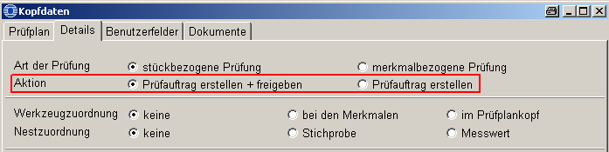
Editable/extensible:
No / No
Additional parameters:
None
Corresponding fields:

Status type: PAUANMELD – Login status of the inspection order
Default entries:
Status | System status | Short description of status | Long description of status | Inactive | Addition
ABGEMELDET | 1 | Log. off | Logged off | 0
ANGEMELDET | 1 | Log. in | Logged in | 0
UNTERBROCHEN | 1 | interr. | interrupted | 0
Description:
Defines the login status of inspection orders
Editable/extensible:
No / No
Additional parameters:
None
Corresponding fields:

Status type: PAUERG – Inspection order results
Default entries:
Status | System  status | Short description  of status | Long description  of status | In-  active | Addition
BEDINGT_IO | 1 | cond. pass | conditionally pass | 0 | [INIT:BEDINGT_IO],[BEDINGT_IO],[RECTYP:PMV]
IO | 1 | pass | pass | 0 | [INIT:IO],[IO],[INIT:SKL]
NIO | 1 | fail | fail | 0 | [INIT:NIO],[NIO]
Description:
Editable/extensible:
No / No
Additional parameters:
[IO] Identifies the status representing the "pass" inspection order result ???
[NIO] Identifies the status representing the "fail" inspection order result ???
[BEDINGT_IO] Identifies the status representing the "conditionally pass" inspection order result ???
[INIT:NIO] Identifies the status of the inspection order result that is to be set if the inspection result of a corresponding characteristic (status type: PAUERG) is "conditionally fail".
[INIT:BEDINGT_IO] Identifies the status of the inspection order result that is to be set if the inspection result of a corresponding characteristic (status type: PAUERG) is "conditionally pass".
[INIT:IO] Identifies the status of the inspection order result that is to be set if the inspection result of a corresponding characteristic (status type: PAUERG) is "conditionally pass".
[INIT:SKL] Identifies the status of the inspection request result that is to be set if the inspection requirement and/or all relevant inspection orders are in the "skip lot" status, i.e. are not checked.
[RECTYP:<RECTYPE>] ???
Corresponding fields:
Example:

Status type: PAUPPLATZ – Options for relations between inspection orders and inspection stations
Default entries:
Status | System status | Short description of status | Long description of status | Inactive | Addition
PAU1PP | 1 | One inspection order for all inspection stations | One inspection order for all inspection stations | 0
PAUxPP | 1 | One inspection order for each inspection station | One inspection order for each inspection station | 0
Description:
Defines the radio buttons specifying the configuration type to generate inspection orders concerning inspection stations.
Editable/extensible:
No / No
Additional parameters:
None
Corresponding fields:

Status type: PAUSTATUS – Inspection order status
Default entries:
Status | System status | Short description of status | Long description of status | Inactive | Addition
 | 1 | Miscellaneous | Miscellaneous | 0 | [BGC:12632256],[FGC:0],[NUMWERT:0]
ABG | 1 | compl. | completed | 0 | [BGC:65280],[FGC:0],[NUMWERT:100]
ERG | 1 | Result | Result | 0 | [BGC:8454143],[FGC:0],[NUMWERT:100]
ERS | 1 | created | created | 0 | [BGC:255],[FGC:0],[NUMWERT:0]
FRE | 1 | released | released | 0 | [BGC:4227327],[FGC:0],[NUMWERT:0]
IPR | 1 | under test | under test | 0 | [BGC:65535],[FGC:0],[NUMWERT:50]
KMM | 1 | no charact. | No characteristic | 0 | [BGC:4227200],[FGC:0],[NUMWERT:100]
SKL | 1 | Skip lot | Skip lot | 0 | [BGC:4227200],[FGC:0],[NUMWERT:100]
STO | 1 | Canceled | Canceled | 0 | [BGC:4227200],[FGC:0],[NUMWERT:100]
TER | 1 | Part. res. | Partial result | 0 | [BGC:65535],[FGC:0],[NUMWERT:50]
Description:
Defines the possible inspection order statuses
Editable/extensible:
No / No
Additional parameters:
[BGC:xyz] Background color
[FGC:xyz] Foreground color
[NUMWERT:xyz] ???
Corresponding fields:
Example:

Status type: PMSTATUS – Test equipment (gage) status
Default entries:
Status | System status | Short description of status | Long description of status | Inactive | Addition
AUSGEMUSTERT | 0 | disc. | discarded | 0 | [VERLEIH:NO]
FREIGEGEBEN | 0 | rel. | released | 0 | [INIT:IO],[INIT:BEDINGT_IO]
GESPERRT | 0 | blocked | blocked | 0 | [INIT:NIO],[VERLEIH:NO]
REPARATUR | 0 | Rep. | Repair | 0 | [VERLEIH:NO]
Description:
Defines the possible statuses of a test equipment (gage). Taking the additional parameters into account, customizing enables to create additional statuses required by the customer.
Example:
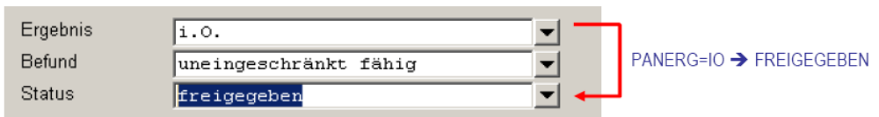
Editable/extensible:
Yes / Yes
Additional parameters:
[INIT:IO] Identifies the status that is to be assigned automatically by default, once calibration has been finished and the inspection requirement result (status type: PANERG) is "pass".
[INI:NIO] Identifies the status that is to be assigned automatically by default, once calibration has been finished and the inspection requirement result (status type: PANERG) is "fail".
[INIT:BEDINGT_IO] Identifies the status that is to be assigned automatically by default, once calibration has been finished and the inspection requirement result (status type: PANERG) is "conditionally pass".
[VERLEIH:NO] Identifies the status of the test equipment specifying it must not be handed out/lent.
[IGNORE] If a status includes this identifier, a test equipment assigned to this status cannot be assigned/used in the inspection order characteristic and/or in measurement recording.
Corresponding fields:

Status type: PMVANZEXTEINF – PMV number of external influences
Default entries:
Status | System status | Short description of status | Long description of status | Inactive | Addition
1 | 1 | 1 - A | 1 - A | 0
2 | 1 | 2 - A B | 2 - A B | 0 | [INIT]
3 | 1 | 3 - A B C | 3 - A B C | 0
Description:
Defines the fields to select the number of external influences in inspection plan characteristics. These fields are shown by selecting the PMV inspection method according to QS-9000 (status type: PMVPRFVER).
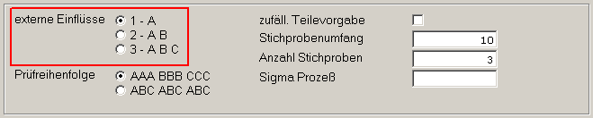
Editable/extensible:
No / No
Additional parameters:
[INIT] Initial default assignment
Corresponding fields:

Status type: PMVMSABEZUG – PMV reference value for MSA capability test
Default entries:
Status | System status | Short description of status | Long description of status | Inactive | Addition
GESSTREUUNG | 1 | Overall dispersion | Overall dispersion | 0 | [INIT]
PROZSTREUUNG | 1 | Process variation | Process variation | 0
TOLERANZ | 1 | Tolerance | Tolerance | 0
Description:
Defines the fields to select the reference value for the capability test in inspection plans. These fields are shown by selecting the PMV inspection method according to QS-9000 (status type: PMVPRFVER).
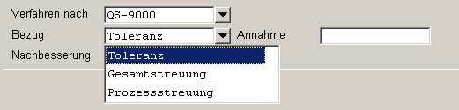
Editable/extensible:
No / No
Additional parameters:
[INIT] Initial default assignment
Corresponding fields:

Status type: PMVPRFBEFUND – Results of calibration/maintenance
Default entries:
Status | System status | Short description of status | Long description of status | Inactive | Addition
BEDINGT | 0 | Conditional | Conditionally capable | 0 | [INIT:BEDINGT_IO]
FAEHIG | 0 | capable | Capable without restrictions | 0 | [INIT:IO]
NFAEHIG | 0 | not capable | not capable | 0 | [INIT:NIO]
UNBEST | 0 | indetermined | indetermined | 0 | [INIT]
Description:
Defines the possible results of a test equipment (gage). Taking the additional parameters into account, customizing enables to create additional results required by the customer.
(See the status type: PMVSTATUS to assign the test equipment status by default)
Editable/extensible:
No / No
Additional parameters:
[INIT:IO] Identifies the result that is to be assigned automatically by default, once calibration has been finished and the inspection requirement result (status type: PANERG) is "pass".
[INI:NIO] Identifies the result that is to be assigned automatically by default, once calibration has been finished and the inspection requirement result (status type: PANERG) is "fail".
[INIT:BEDINGT_IO] Identifies the result that is to be assigned automatically by default, once calibration has been finished and the inspection requirement result (status type: PANERG) is "conditionally pass".
Corresponding fields:

Status type: PMVPRFREIHENF – PMV inspection sequence
Default entries:
Status | System status | Short description of status | Long description of status | Inactive | Addition
AAA_BBB_CCC | 1 | AAA BBB CCC | AAA BBB CCC | 0 | [INIT]
ABC_ABC_ABC | 1 | ABC ABC ABC | ABC ABC ABC | 0
Description:
Defines the inspection sequence in inspection plan characteristics of PMV inspection plans. These fields are shown by selecting the PMV inspection method according to QS-9000 (status type: PMVPRFVER).
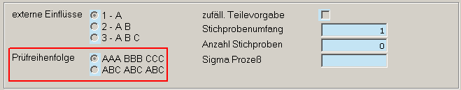
Editable/extensible:
No / No
Additional parameters:
[INIT] Initial default assignment
Corresponding fields:

Status type: PMVPRFVER – PMV inspection procedure
Default entries:
Status | System status | Short description of status | Long description of status | Inactive | Addition
QS9000 | 1 | QS-9000 | QS-9000 | 0
STD | 1 | Standard | Standard | 0 | [INIT]
Specific entries:
QS9000_ANOVA
Description:
Defines the possible selection options for the PMV inspection procedure within inspection plan headers
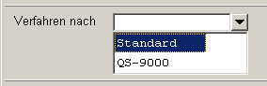
Editable/extensible:
No / No
Additional parameters:
[INIT] parameter is currently not functioning.
Please note
Warning!!
The Status QS9000_ANOVA is created by the DB patch dbp_caq_pmv_qs9000_anova.hsc (it is first of all inactive) and must not be created manually. Enabling or disabling of an existing status can be carried out.
If this status is active, it leads to the field caq_merkmal.pmv_stat_ia being maintained in the relevant programs. If this field is unavailable it leads to errors (it is also created by the DB Patch dbp_caq_pmv_qs9000_anova.hsc).
Corresponding fields:

Status type: PMVPRUEFTYP – PMV inspection types
Default entries:
Status | System status | Short description of status | Long description of status | Inactive | Addition
KALIB | 1 | Calib. | Calibration | 0
WART | 1 | Maint. | Maintenance | 0
Description:
Defines the inspection types in PMV work plans
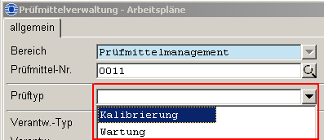
Editable/extensible:
No / No
Additional parameters:
None
Corresponding fields:

Status type: PMVVERWEND – Usage types for test equipment (gages)
Default entries:
Status | System status | Short description of status | Long description of status | Inactive | Addition
KALIBRATOR | 0 | Calibrator | Calibrator | 0
MASCHINE | 0 | Machine | Machine | 0
MESSKETTE | 0 | Measuring chain | Measuring chain | 0
MESSMITTEL | 0 | Measuring equipment | Measuring equipment | 0
PRUEFMITTEL | 0 | Test equipment (gages) | Test equipment (gages) | 0 | [INIT]
WMASCHINE | 0 | Mach. tool | Machine tool | 0
Description:
Defines the possible usage types for the test equipment managed in PMV. Customizing allows to add further statuses.
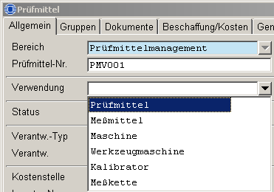
Editable/extensible:
Yes / Yes
Additional parameters:
[INIT] Initial default assignment when creating test equipment in the PMV module.
Corresponding fields:

Status type: PMVVORHSGEN – ???
Default entries:
Status | System status | Short description of status | Long description of status | Inactive | Addition
99 | 1 | 99.00 % | 99.00 % | 0 | [INIT]
99.75 | 1 | 99.75 % | 99.75 % | 0
Description:
Needs to be added
Editable/extensible:
No / No
Additional parameters:
[INIT] Initial default assignment
Corresponding fields:
Example:

Status type: PPKTTYP – Types of inspection points
Default entries:
Status | System status | Short description of status | Long description of status | Inactive | Addition
EQUIPMENT | 1 | Equipm. | Equipment | 0
FERTIGUNG | 1 | in-prod. | in-production | 0 | [INIT]
PHYS_PROBE | 1 | phys. sample | physical sample | 0
TECHN_PLATZ | 1 | Funct. loc. | Functional location | 0
Description:
Defines the types of inspection points- → Where is it required?
Editable/extensible:
Yes / No
Additional parameters:
[INIT] Initial default assignment when creating an inspection point
Corresponding fields:

Status type: PPLAGCFG – Options for relations between inspection plans and operations
Default entries:
Status | System status | Short description of status | Long description of status | Inactive | Addition
PPL1AG | 1 | One inspection plan for each OP | One inspection plan for each OP | 0
PPLxAG | 1 | One inspection plan for all OPs | One inspection plan for all OPs | 0
Description:
Defines the settings whether an inspection plan is created for all operations (operation is stored in the inspection plan header) or if the inspection plan applies to each operation (OP is defined for the inspection plan characteristic).
Editable/extensible:
No / No
Additional parameters:
None
Corresponding fields:

Status type: PPLSTATUS – Inspection plan status
Default entries:
Status | System status | Short description of status | Long description of status | Inactive | Addition
 | 1 | in proc. | in process | 0 | [BGC:12632256],[FGC:0]
AKTIV | 1 | active | active | 0 | [BGC:65280],[FGC:0]
FREIGABE | 1 | released | released | 0 | [BGC:65535],[FGC:0]
Description:
Defines the possible inspection plan statuses
Editable/extensible:
No / No
Additional parameters:
[BGC:xyz] Background color
[FGC:xyz] Foreground color
Corresponding fields:

Status type: PPLSUCH_AG – Methods to search for inspection plans (operation)
Default entries:
Status | System status | Short description of status | Long description of status | Inactive | Addition
AG:NR_BEZ_PPLKOP | 1 | Inspection plan header | Search in inspection plan header | 0
AG:NR_BEZ_PPLMER | 1 | Inspection plan characteristics | Search in inspection plan characteristics | 0
Description:
Defines the operation-related search methods, searching in the inspection plan header or in inspection plan characteristics. Option 1/option 2 of the configuration of options defines the order of searching inspection plans/specification list entries.
Editable/extensible:
No / No
Additional parameters:
None
Corresponding fields:

Status type: PPLSUCH_ATK – Methods to search for inspection plans (article data)
Default entries:
Status | System status | Short description of status | Long description of status | Inactive | Addition
ATK:GRP | 1 | Group | Group search | 0
ATK:NR | 1 | No. | only use number | 0
ATK:NR_IDX | 1 | No. + drawing issue number | Use number and drawing issue number | 0

Description:
Defines the article-related search methods, search by article group, article number or article number and article index. Option 1/option 2 of the configuration of options defines the order of searching inspection plans/specification list entries.
Editable/extensible:
No / No
Additional parameters:
None
Corresponding fields:

Status type: PPLSUCH_KD – Methods to search for inspection plans (customer data)
Default entries:
Status | System status | Short description of status | Long description of status | Inactive | Addition
KD:GRP | 1 | Group | Group search | 0
KD:NR | 1 | No. | Use number | 0
Description:
Defines the customer-specific search methods, search customer's group number or customer number. Option 1/option 2 of the configuration of options defines the order of searching inspection plans/specification list entries.
Editable/extensible:
No / No
Additional parameters:
None
Corresponding fields:

Status type: PPLSUCH_LIEF – Methods to search for inspection plans (supplier data)
Default entries:
Status | System status | Short description of status | Long description of status | Inactive | Addition
LIEF:GRP | 1 | Group | Group search | 0
LIEF:NR | 1 | No. | Use number | 0
Description:
Defines supplier-related search methods, search for supplier group number or supplier number. Option 1/option 2 of the configuration of options defines the order of searching inspection plans/specification list entries.
Editable/extensible:
No / No
Additional parameters:
None
Corresponding fields:

Status type: PRFERG_MM – Inspection results of characteristics
Default entries:
Status | System status | Short description of status | Long description of status | Inactive | Addition
BEDINGT_IO | 1 | cond. pass | conditionally pass | 0 | [IO],[DYN:NIO],[INIT:BEDINGT_IO]
IO | 1 | pass | pass | 0 | [IO],[DYN:IO],[INIT:IO]
NIO | 1 | fail | fail | 0 | [NIO],[DYN:NIO],[INIT:NIO]
UNGEPR | 1 | unch. | unchecked | 0 | [INIT],[IO],[DYN:IO]
Description:
Defines the statuses of the inspection results of characteristics
Editable/extensible:
No / No
Additional parameters:
[IO] Identifies the statuses representing the characteristic result "pass" ???
[NIO] Identifies the statuses representing the characteristic result "fail" ???
[INIT:NIO] Identifies the status of the characteristic result that is to be set for the inspection result "fail" of a relevant sample (status type: PRFERG_STPR).
[INIT:BEDINGT_IO] Identifies the status of the characteristic result that is to be set for the inspection result "conditionally pass" of a relevant sample (status type: PRFERG_STPR).
[INIT] Initial default assignment when generating an inspection order characteristic
[INIT:IO] Identifies the status of the characteristic result that is to be set for the inspection result "pass" of a relevant sample (status type: PRFERG_STPR).
[DYN:IO] ???
[DYN:NIO] ???
Corresponding fields:

Status type: PRFERG_STPR – Inspection results of samples
Default entries:
Status | System status | Short description of status | Long description of status | Inactive | Addition
BEDINGT_IO | 1 | cond. pass | conditionally pass | 0 | [IO],[DYN:NIO]
IO | 1 | pass | pass | 0 | [IO],[DYN:IO]
NIO | 1 | fail | fail | 0 | [NIO],[DYN:NIO]
UNGEPR | 1 | unch. | unchecked | 0 | [INIT],[IO],[DYN:IO]
Description:
Defines the statuses of samples
Editable/extensible:
No / No
Additional parameters:
[IO] Identifies the statuses representing the sample result "pass"???
[NIO] Identifies the statuses representing the sample result "fail" ???
[INIT] Initial default assignment when generating a sample
[DYN:IO] ???
[DYN:NIO] ???
Corresponding fields:

Status type: PRFZUSTAND – Inspection statuses
Default entries:
Status | System status | Short description of status | Long description of status | Inactive | Addition
ABSCHLUSS | 0 | Final inspection | Final inspection | 0
FREIGABE | 0 | Release check | Release check | 0
NORMAL | 0 | Normal inspection | Normal inspection | 0
SPC | 0 | SPC inspection | SPC inspection | 0 | [INT]
Description:
Could not be found within the sources by CJD --> probably the status is not used.
Editable/extensible:
No / No
Additional parameters:
[init] Initial default assignment
Corresponding fields:

Status type: PRUEFART – Inspection types
Default entries:
Status | System status | Short description of status | Long description of status | Inactive | Addition
MERKMAL | 1 | Inspection based on characteristics | Inspection based on characteristics | 0
STUECK | 1 | Inspection based on pieces | Inspection based on pieces | 0

Description:
Defines the inspection type to be selected in the inspection plan:
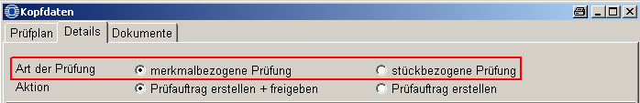
Editable/extensible:
No / No
Additional parameters:
None
Corresponding fields:

Status type: PRUEFTYP – Inspection types
Default entries:
Status | System status | Short description of status | Long description of status | Inactive | Addition
A | 1 | Attributive | Attributive | 0
F | 1 | Inspection chart | Inspection chart | 2
I | 1 | Info | Information | 0
V | 1 | Variable | Variable | 0
Description:
Defines the characteristic types that can be selected in the configuration of characteristics. There are different input options subject to the characteristic type.
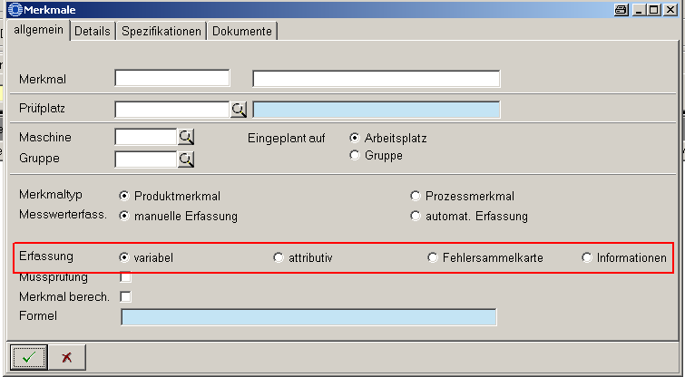
Editable/extensible:
No / No
Additional parameters:
[init] Initial default assignment
Corresponding fields:
MOC Characteristic master data

Status type: PRUEFUMF – Status of inspection scopes
Default entries:
Status | System status | Short description of status | Long description of status | Inactive | Addition
EGAL | 1 | immaterial (egal) | may be less or greater than | 0
GENAU | 1 | Exactly | Must be adhered to exactly | 0 | [INIT]
GROESSER | 1 | greater | may be greater | 0
KLEINER | 1 | Less | may be less | 0
Description:
Needs to be complemented
Editable/extensible:
Yes / No
Additional parameters:
[init] Initial default assignment
Corresponding fields:

Status type: QMS_ART – QMS - Type of inspection requirements
Default entries:
Status | System status | Short description of status | Long description of status | Inactive | Addition
01 | 0 | Goods receipt inspec. f. ord. | Goods receipt inspection for order process | 0
0101 | 0 | Goods receipt samp. inspec. f. ord. | Goods receipt sample inspection for order process | 0
0130 | 0 | Receiving insp. ext. proc. | Goods received inspection from external processing | 0
02 | 0 | Goods issue | Goods issue WAP | 0
03 | 0 | Prod. | Production order FEP | 0 | [INIT]
04 | 0 | Goods receipt FA | Goods receipt from production order | 0
05 | 0 | Gen. goods receipt | General goods receipt | 0
06 | 0 | Return | Returns from customer | 0
07 | 0 | Audit | Audit | 0
08 | 0 | Stock transfer | Stock transfer | 0
0800 | 0 | Insp. batch if QM active | Inspection batch including inspection stock if QM is activated | 0
10 | 0 | Del. with cust. ord. | Delivery to customer with customer order | 0
11 | 0 | Del. without cust. ord. | Delivery to the customer without customer order | 0
12 | 0 | Gen. del. | General delivery | 0
89 | 0 | All | All | 0

Description:
Defines the type of inspection requirements in connection with QMS. If necessary, additional information by CTK
Editable/extensible:
Yes / Yes
Additional parameters:
[init] Initial default assignment
Corresponding fields:

Status type: QMS_HERKUNFT – QMS - origin of the inspection requirement
Default entries:
Status | System status | Short description of status | Long description of status | Inactive | Addition
01 | 0 | Receiving insp. | Goods receipt inspection | 0
02 | 0 | Goods issue | Goods issue WAP | 0
03 | 0 | Prod. | Production order FEP | 0 | [INIT]
04 | 0 | Goods receipt FA | Goods receipt from production order | 0
05 | 0 | Gen. goods receipt | General goods receipt | 0
06 | 0 | Return | Returns from customer | 0
07 | 0 | Audit | Audit | 0
08 | 0 | Stock transf. | Stock transfer | 0
10 | 0 | Del. with cust. ord. | Delivery to customer with customer order | 0
11 | 0 | Del. without cust. ord. | Delivery to the customer without customer order | 0
12 | 0 | Gen. del. | General delivery | 0
89 | 0 | All | All | 0
Description:
Defines the origin of the inspection requirement. If necessary, additional information
Editable/extensible:
Yes / Yes
Additional parameters:
[init] Initial default assignment
Corresponding fields:

Status type: QM_AG_CREATE – Generate operations if required
Default entries:
Status | System status | Short description of status | Long description of status | Inactive | Addition
KEINE | 1 | None | None | 0
PAN_CREATE | 1 | Generating new insp. req. | Generating new inspection requirements | 0
PAU_CREATE | 1 | Generating new insp. ord. | Generating new inspection orders | 1
Description:
Status required as part of the new ADE-CAQ integration. Please also see:
\\archive\mast_ind\HYDRA-Produkte\CAQ\Konzepte\ADE_CAQ_Integration\CAQ_ADE_Integration_2_V13.doc
No (by default)
When generating new inspection requirements, the structure of working plans is not changed and no new, true QM OPs are created.
Generating new inspection requirements
When generating inspection requirements, new true QM OPs are created if needed.
When generating new inspection orders (inactive therefore not visible in the inspection plan)
If generating an inspection step a new true QM OP is created if it does not yet exist.
Editable/extensible:
No / yes
Additional parameters:
None
Corresponding fields:

Status type: QUELLEDET – Sources for characteristic details
Default entries:
Status | System status | Short description of status | Long description of status | Inactive | Addition
MERKAT | 1 | Charact. catalog | from characteristics catalog | 0
PPLMER | 1 | Inspection plan | from inspection plan | 0
Description:
Defines whether or not the characteristic details are to be taken from the inspection plan characteristic or the catalog of characteristics master data when generating an inspection order characteristic. This configuration is made in the inspection plan characteristics.
Editable/extensible:
No / No
Additional parameters:
None
Corresponding fields:

Status type: QUELLEDOKU – Source of documents
Default entries:
Status | System status | Short description of status | Long description of status | Inactive | Addition
LISTE | 0 | List | from list | 0
MERKAT | 0 | Charact. catalog | from characteristics catalog | 0
PPLMER | 0 | Inspection plan | from inspection plan | 0
Description:
Defines from which configuration the documents are to be taken over when generating inspection order characteristics. If "LISTE" is selected, an appropriate entry is searched for in the list of documents.
Editable/extensible:
No / No
Additional parameters:
None
Corresponding fields:

Status type: QUELLESPEZ – Sources for characteristic specifications
Default entries:
Status | System status | Short description of status | Long description of status | Inactive | Addition
LISTE | 1 | List | from list | 0
MERKAT | 1 | Charact. catalog | from characteristics catalog | 0
PPLMER | 1 | Inspection plan | from inspection plan | 0
Description:
Defines from which configuration the specifications are to be taken over when generating inspection order characteristics. If "LISTE" is selected, an appropriate entry is searched for in the specification list.
Editable/extensible:
No / No
Additional parameters:
None
Corresponding fields:

Status type: RECTYP – Data types
Default entries:
Status | System status | Short description of status | Long description of status | Inactive | Addition
 | 1 | Miscellaneous | Miscellaneous | 0
CPL | 1 | Control Plan | Control Plan | 0
EMU | 1 | Initial sample | Initial sample inspection | 0
FEP | 1 | Production | Inspection during production | 0
LFB | 1 | Supplier evaluation | Supplier evaluation | 0
MAS | 1 | Measure | Measure | 0
PMV | 1 | Test equipment (gages) | Test equipment (gage) management | 0
QMS | 1 | QM Subs. | QM sub system | 0
REK | 1 | Complaint | Complaints management | 0
WAP | 1 | Goods issue | Goods issue inspection | 0
WEP | 1 | Goods receipt | Goods receipt inspection | 0

Description:
Defines the possible REC types, i.e. CAQ modules. REC types are used, among other things, as key in different CAQ tables to be able to assign data records to the different REC types.
Editable/extensible:
No / No
Additional parameters:
None
Corresponding fields:

Status type: REGELK – Control Charts
Default entries:
Status | System  status | Short description  of status | Long description of status | In-  active | Addition
C | 1 | c | c chart | 0 | [A],[SPSTAT],[NOPPL],[QMS_1:195],  [QMS_1:196]
CP | 1 | cp | cp- chart | 0 | [V]
CPK | 1 | cpk | cpk chart | 0 | [V]
EWMA | 1 | EWMA | EWMA-XQ chart | 1 | [V],[SPSTAT],[NOPPL],[QMS_1:530],  [QMS_1:531],[QMS_1:535],[QMS_1:536]
IR | 1 | IR | IR chart | 0 | [V],[SPSTAT_MOVE],[SPBASIS:2],[NOPPL],  [QMS_1:515],[QMS_1:516]
NP | 1 | np | np chart | 0 | [A],[SPSTAT],[QMS_1:175],[QMS_1:176]
P | 1 | p | p chart | 0 | [A],[SPSTAT],[QMS_1:165],[QMS_1:166]
R | 1 | R | R chart | 0 | [V],[SPSTAT]
R_MOV | 1 | float. R | floating R chart | 0 | [V],[SPSTAT_MOVE],[SPBASIS:2]
S | 1 | s | s chart | 0 | [V],[QMS_1:120],[QMS_1:121],[QMS_2:210],  [QMS_2:211],[QMS_2:215],[QMS_2:410],  [QMS_2:411]
SREL | 1 | s (rel.) | s chart (relative) | 1 | [V],[SPSTAT]
S_MOV | 1 | float. s | floating s chart | 1 | [V],[SPSTAT_MOVE]
U | 1 | u | u chart | 0 | [A],[SPSTAT],[QMS_1:185],[QMS_1:186]
X | 1 | Single value | Single value chart | 0 | [V],[SPSTAT]
XQ | 1 | XQ | XQ chart | 0 | [V],[SPSTAT],[QMS_1:110],[QMS_1:111],  [QMS_1:112],[QMS_1:115],[QMS_1:116],  [QMS_1:210],[QMS_1:211],[QMS_1:215],  [QMS_1:216],[QMS_1:310],[QMS_1:311],  [QMS_1:312],[QMS_1:410],[QMS_1:411]
XQ_MOV | 1 | float. XQ | floating XQ chart | 0 | [V],[SPSTAT_MOVE],[SPBASIS:2],  [QMS_1:520],[QMS_1:521],[QMS_1:525],  [QMS_1:526]
X_MED | 1 | Median chart | Median chart | 0 | [V],[SPSTAT]
Description:
Defines the control charts available in CAQ
Editable/extensible:
Yes / No
Additional parameters:
[A] identifies the status of control charts for attributive characteristics
[V] identifies the status of control charts for variable characteristics
[SPSTAT] CTK
[SPSTAT_MOVE] CTK
[SPBASIS:xyz] CTK
[NOPPL] CTK
[QMS_1:xyz] CTK
Corresponding fields:

Status type: REKART – Complaint types
Default entries:
Status | System  status | Short description of status | Long description of status | Inactive | Addition
INTERN | 0 | internal | Internal complaint | 0 | [AW:('ABTEILUNG','PERSON')]
KUNDE | 0 | Cutomer compl. | Customer complaint | 0 | [AW:KUNDE],[INIT]
LIEFERANT | 0 | Supplier compl. | Supplier complaint | 0 | [AW:LIEFERANT]
Description:
Defines the type of complaint. Complaint types as well as additional parameters can be complemented and/or modified as part of customizing the system.
Editable/extensible:
Yes / Yes
Additional parameters:
[AW:(´xyz´,´xyz´)] Defines the selection options (>1) of the complaining parties. xyz represents the type of complaining party.
[AW:xyz] Defines the selection options (=1) of the complaining part type. xyz represents the type of complaining party.

Whereas xyz = [ABTEILUNG|PERSON|KUNDE|LIEFERANT|] (department, person, customer, supplier)

[INIT] Initial default assignment when creating a complaint
- This only works with HYDRA 7. For HYDRA 8 this has to be implemented using the Development Suite (liable to costs).
Corresponding fields:
Example:
Status | System  status | Short description of status | Long description of status | Inactive | Addition
INTERN | 0 | internal | Internal complaint | 0 | [AW:('ABTEILUNG','PERSON')]
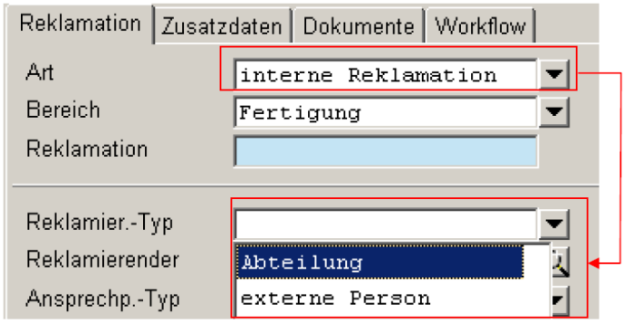

Status type: REKBEFUND – Complaint results
Default entries:
Status | System status | Short description of status | Long description of status | Inactive | Addition
GERECHTF | 0 | justif. | justified | 0
TEILWGER | 0 | Partly justif. | Partly justified | 0
UNBESTIMMT | 0 | indetermined | indetermined | 0 | [INIT]
UNGERECHTF | 0 | unjustif. | unjustified | 0 | [IGN]

Description:
Defines the possible results of the complaint header
Editable/extensible:
Yes / Yes
Additional parameters:
[INIT] Initial default assignment when creating a complaint
[IGN] ignore???
Corresponding fields:

Status type: REKDETBEFUND – Results of complaint details
Default entries:
Status | System status | Short description of status | Long description of status | Inactive | Addition
GARANTIE | 0 | Warranty | Warranty | 0
GERECHTF | 0 | justif. | justified | 0
KULANZ | 0 | Fair dealing/goodwill | Fair dealing/goodwill | 0
TEILWGER | 0 | Partly justif. | Partly justified | 0
UNBESTIMMT | 0 | indetermined | indetermined | 0 | [INIT]
UNGERECHTF | 0 | unjustif. | unjustified | 0 | [IGN]

Description:
Defines the possible results of complaint details
Editable/extensible:
Yes / Yes
Additional parameters:
[INIT] Initial default assignment when creating a complaint detail
[IGN] ignore???
Corresponding fields:

Status type: REKDETSTATUS – Status of complaint details
Default entries:
Status | System  status | Short description of status | Long description of status | In-  active | Addition
ABGESCHL | 0 | compl. | completed | 0 | [ABG],[BGC:65280],[FGC:0],  [NUMWERT:100]
BEARBEIT | 0 | in process | in process | 0 | [OFFEN],[BGC:65535],[FGC:0],  [NUMWERT:50]
ERFASST | 0 | collected | collected | 0 | [INIT],[OFFEN],[BGC:255],[FGC:0],  [NUMWERT:0]
Description:
Defines the possible statuses of a complaint detail
Editable/extensible:
Yes / Yes
Additional parameters:
[INIT] Initial default assignment when creating a complaint detail
[ABG] Identifies the statuses for which the complaint detail is considered being "completed". → What happens to REKDET that have the ABG status?
[OFFEN] Identifies the statuses for which the complaint detail is considered being "open".--> What happens to REKDET that have the OFFEN status?
[BGC:xyz] Background color?
[FGC:xyz] Foreground color?
[NUMWERT:xyz] ?
Corresponding fields:

Status type: REKDOKZUORD – Assignment of documents for complaints
Default entries:
Status | System status | Short description of status | Long description of status | Inactive | Addition
BEMERKUNG | 0 | Comm. | Comment | 0
ERFOLGSKONTR | 0 | Perf. rev. | Performance review | 0
KEINE | 0 | None | no assignment | 0
VORHERSAGE | 0 | Predict. | Prediction | 0
Description:
Defines the possible assignments of documents when assigning documents in the failure tree analysis. They are also printed with the relevant reports.
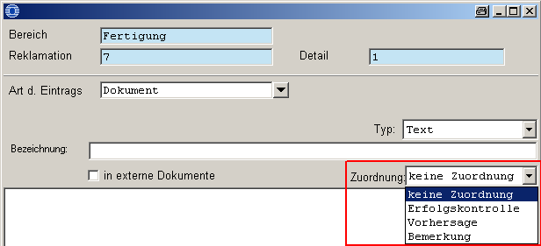
Editable/extensible:
Yes / Yes
Additional parameters:
None
Corresponding fields:

Status type: REKSTATUS – Complaint status
Default entries:
Status | System  status | Short description of status | Long description of status | Inactive | Addition
ABGESCHL | 0 | compl. | completed | 0 | [ABG],[BGC:65280],[FGC:0],  [NUMWERT:100]
BEARBEIT | 0 | in process | in process | 0 | [OFFEN],[BGC:65535],[FGC:0],  [NUMWERT:50]
ERFASST | 0 | collected | collected | 0 | [INIT],[OFFEN],[BGC:255],[FGC:0],  [NUMWERT:0]
Description:
Defines the possible statuses of a complaint
Editable/extensible:
Yes / Yes
Additional parameters:
[INIT] Initial default assignment when creating a complaint
[ABG] Identifies the statuses for which the complaint is considered being "completed". → What happens to REK that have the ABG status?
[OFFEN] Identifies the statuses for which the complaint is considered being "open".--> What happens to REK that have the OFFEN status?
[BGC:xyz] Background color?
[FGC:xyz] Foreground color?
[NUMWERT:xyz] ?
Corresponding fields:

Status type: STAT_VERTEILUNG – Statistical distribution types
Default entries:
Status | System status | Short description of status | Long description of status | Inactive | Addition
BINOMINAL | 1 | Binominal | Binominal distribution | 0
NORMAL | 1 | normal | Normal distribution | 0 | [INIT]
POISSON | 1 | Poisson | Poisson distribution | 0
UNBEKANNT | 1 | unkn. | unknown | 0
Description:
Where are these statuses used?
Editable/extensible:
Yes / No
Additional parameters:
[INIT] Initial default assignment
Corresponding fields:

Status type: STPLPLAN – Sampling schemes
Default entries:
Status | System status | Short description of status | Long description of status | Inactive | Addition
100PRO | 1 | 100% | 100% inspection | 0 | [WEP],[FEP],[WAP],[EMU]
K | 1 | k value | k value inspection | 0
LOS | 1 | Batch | Batch inspection | 0 | [WEP],[WAP]
NC | 1 | n-c | n-c inspection | 0 | [WEP],[FEP],[WAP],[PMV]
SPC | 1 | SPC | SPC inspection | 0 | [FEP]
Description:
Defines the sampling schemes of characteristics. The additional parameters specify in which Rec types the sampling schemes are available.
Editable/extensible:
No / No
Additional parameters:
[xyz] RECTYP for which the sampling scheme is available in inspection plan and inspection order characteristics.
Corresponding fields:

Status type: TABELLENREF – Table reference
Default entries:
Status | System status | Short description of status | Long description of status | Inactive | Addition
caq_dokus | 1 | Document | Document | 0
caq_fhlanal | 1 | Defect entry | Defect entry | 0
caq_kosten | 1 | Cost rate | Cost rate | 0
caq_massn | 1 | Measure | Measure | 0
caq_merkmal | 1 | Characteristic | Characteristic | 0
Description:
Statuses are used as selection type when creating an entry in the analysis tree within complaint management.
Editable/extensible:
No / No
Additional parameters:
None
Corresponding fields:

Status type: VERANTWTYP – Types of responsibilities
Default entries:
Status | System status | Short description of status | Long description of status | Inactive | Addition
ABTEILUNG | 1 | Department | Department | 0
HERSTELLER | 1 | Manufacturer | Manufacturer | 0
INTERN | 1 | int. company | internal company | 0
KUNDE | 1 | Customer | Customer | 0
LIEFERANT | 1 | Supplier | Supplier | 0
PERSON | 1 | ext. pers. | external person | 0
PZE_PERSON | 1 | Person | Person | 0
VERTEILER | 1 | Distribution list | Distribution list | 0
Description:
Defines the possible types of responsible parties.
Editable/extensible:
No / No
Additional parameters:
None
Corresponding fields:

Status type: VERTEILVTYP – Types of responsibilities for distribution lists
Default entries:
Status | System status | Short description of status | Long description of status | Inactive | Addition
ABTEILUNG | 1 | Department | Department | 0
HERSTELLER | 1 | Manufacturer | Manufacturer | 0
INTERN | 1 | int. company | internal company | 0
KUNDE | 1 | Customer | Customer | 0
LIEFERANT | 1 | Supplier | Supplier | 0
PERSON | 1 | ext. pers. | external person | 0
PZE_PERSON | 1 | Person | Person | 0
Description:
Defines the responsible parties for distribution lists
Editable/extensible:
No / No
Additional parameters:
None
Corresponding fields:

Status type: WERKZUORD – Tool assignment
Default entries:
Status | System status | Short description of status | Long description of status | Inactive | Addition
KEINE | 1 | None | None | 0
PPLKOP | 1 | in inspection plan header | in inspection plan header | 0
PPLMER | 1 | for characteristics | for characteristics | 0
Description:
Defines the type of tool assignment. Globally for all characteristics included in the inspection plan header or one tool assignment for each inspection plan characteristic.
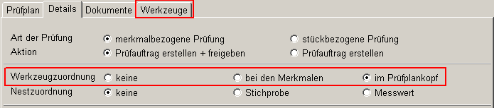
Editable/extensible:
No / No
Additional parameters:
None
Corresponding fields:

Status type: WFELEMENTTYP – Types of workflow steps
Default entries:
Status | System  status | Short description of status | Long description of status | In-  active | Addition
KEINE | 1 | no assignm. | no assignment | 0
REKDETANALYSE | 0 | Detailed analysis | Detailed analysis | 0 | [RECTYPE:REK],  [RECREF:RKD]
REKDETDOKU | 1 | Detailed documents | Detailed documents | 0 | [RECTYPE:REK],  [RECREF:RKD]
REKDETKOPF | 1 | Detailed header data | Detailed header data | 0 | [RECTYPE:REK],  [RECREF:RKD]
REKDETKOSTEN | 1 | Detailed costs | Detailed costs | 0 | [RECTYPE:REK],  [RECREF:RKD]
REKDETMASSN | 1 | Detailed measures | Detailed measures | 0 | [RECTYPE:REK],  [RECREF:RKD]
REKDOKU | 1 | Complaint documents | Complaint - documents | 0 | [RECTYPE:REK]
REKKOPF | 1 | Complaint header data | Complaint header data | 0 | [RECTYPE:REK]
REKKOSTEN | 1 | Compl. costs | Complaint costs | 0 | [RECTYPE:REK]
REKMASSN | 1 | Complaint measures | Complaint measures | 0 | [RECTYPE:REK]
Description:
Defines the types of workflow elements. Currently, this status type has no functional effects.
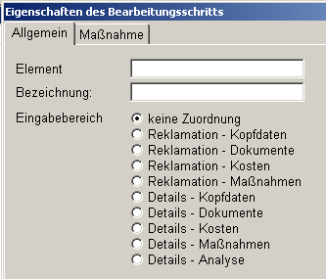
Editable/extensible:
No / No
Additional parameters:
[RECTYPE:REK] Workflow element pertains to REC type REK
[RECREF:RKD] Workflow element refers to a complaint detail
Corresponding fields:

Status type: WFREF – Reference of workflows
Default entries:
Status | System status | Short description of status | Long description of status | Inactive | Addition
RKD | 1 | Complaint details | Complaint details | 0 | [RECTYPE:REK]
RKK | 1 | Complaint header | Complaint header | 0 | [RECTYPE:REK]
Description:
Defines the workflow reference to the corresponding object (REK detail or REK header). At the moment only Complaint Management uses workflows.
Editable/extensible:
No / No
Additional parameters:
[RECTYP:REK] Workflow pertains to Complaint Management
Corresponding fields:

Status type: WFTYP – Workflow types
Default entries:
Status | System status | Short description of status | Long description of status | Inactive | Addition
REK | 1 | Complaint | Complaint | 0
Description:
Defines the workflow types. At the moment only Complaint Management uses workflows.
Editable/extensible:
No / No
Additional parameters:
None
Corresponding fields:

Status type: ZERTIFDRU – Print options for certificates
Default entries:
Status | System status | Short description of status | Long description of status | Inactive | Addition
AUSW | 1 | Selection | Show selection | 0
IMMER | 1 | always | print always | 0
NIE | 1 | never | never print | 0

Description:
Defines the options for printing certificates in the configuration of characteristics:
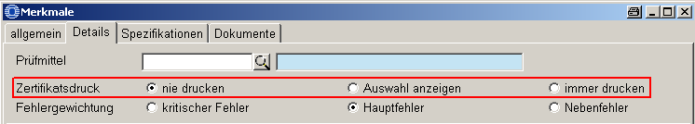
Editable/extensible:
No / No
Additional parameters:
None
Corresponding fields:

Status type: Template – template for the description of a status type
Default entries:
Description:
Editable/extensible:
No / No
Additional parameters:
[INIT] Initial default assignment
Corresponding fields:

